Fewer than 200 serious injuries and deaths on our roads by 2026
Towards Zero
Tasmanian Road Safety Strategy 2017-2026

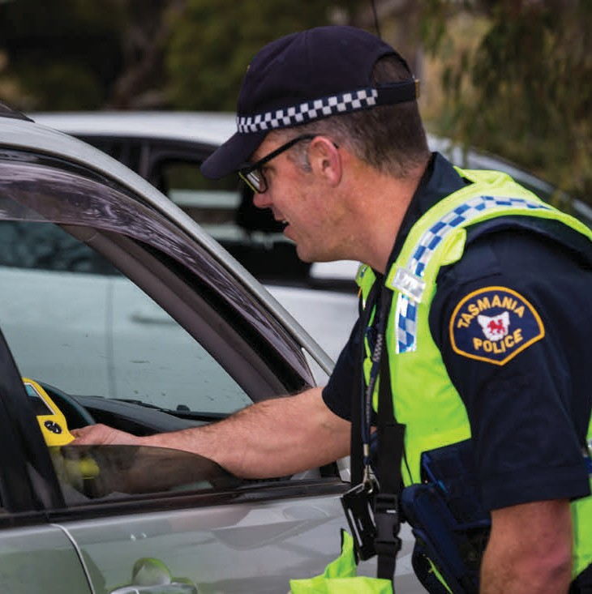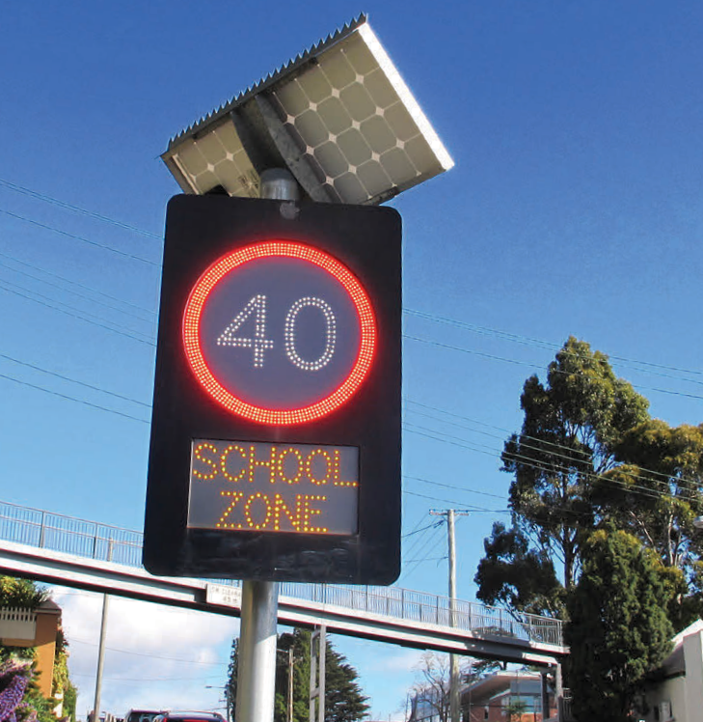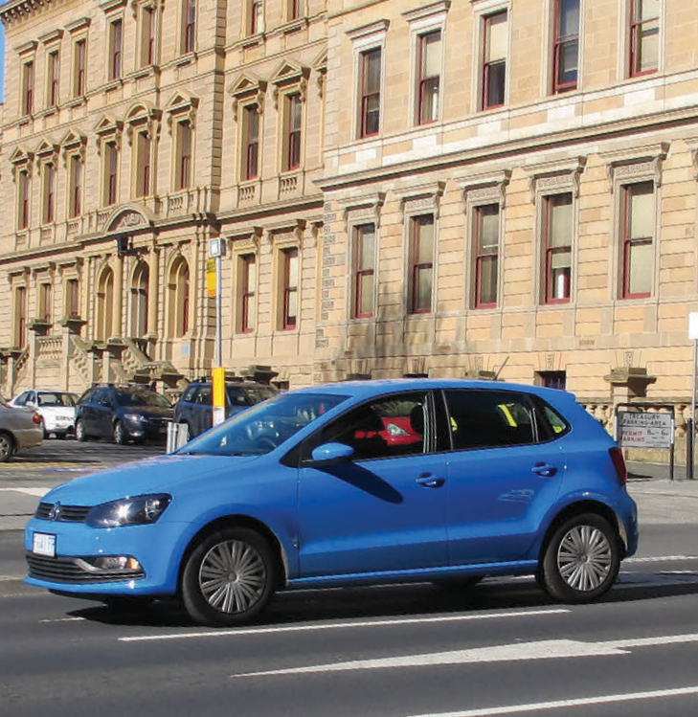
Department of State Growth

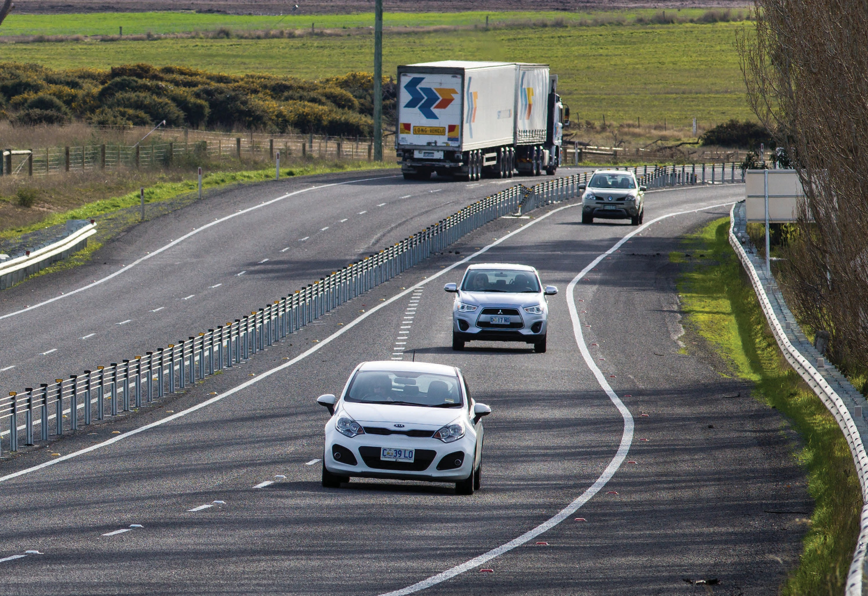

Contents

Minister’s foreword 4
Message from the Chair of the Tasmanian Road Safety Advisory Council 5
Snapshot 7
Our vision 8
Our target 9
Not just a number 10
Tasmanian road crashes 11
The Safe System approach 18
The way forward 20
Working Towards Zero 30
Glossary of terms 31

Copyright notice and disclaimer
Copyright in this publication is owned by the Crown in Right of Tasmania, represented by the Department of State Growth.
Information in this publication is intended for general information only and does not constitute professional advice and should not be relied upon as such. No representation or warranty is made as to the accuracy, reliability or completeness of any information in this publication. Readers should make their own enquiries and seek independent professional advice before acting on or relying upon any of the information provided.
The Crown, its officers, employees and agents do not accept liability however arising, including liability for negligence, for any loss resulting from the use of or reliance upon information in this publication.
Images used within this publication remain the property of the copyright holder. For further information on this publication please visit www.stategrowth.tas.gov.au
© State of Tasmania December 2016
Photo credits
Images courtesy of ANCAP and the Tasmanian Government.

Minister’s foreword

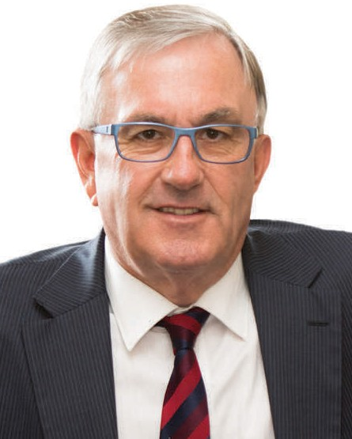As Minister responsible for safety on Tasmanian roads, I am fully committed to working towards a reality where no one is seriously injured or killed as a result of a crash. We are a long way from this reality but I strongly believe that this Towards Zero – Tasmanian Road Safety Strategy 2017-2026 (Towards Zero Strategy) will help to make significant progress.
Over the past 15 years we have seen a steady reduction in the number of serious injuries and deaths on our roads. However, the numbers have recently started to plateau and we still see around 300 people being seriously injured or losing their lives on our roads each year. Sadly, I believe Tasmanians have become far too accepting of serious injuries and death on our roads. So, to keep reducing road trauma, we need to strive for better road safety outcomes together.
Our Towards Zero Strategy has set a short-term, ambitious target of reducing the number of annual serious injuries and fatalities on Tasmania’s roads to fewer than 200 by the year 2026. To achieve this goal and to keep moving towards our ultimate vision of zero, we need to continue to adopt the ‘Safe System’ approach to road safety. This approach recognises that people make mistakes and considers how the whole road system can be made more forgiving, so mistakes don’t cost lives. We will continue, of course, to do everything in our power to prevent illegal and negligent road user behaviour.
The Strategy outlines a set of new key directions to improve the safety of Tasmania’s roads, vehicles, speeds and road users. By considering Tasmania’s crash problem, technology advancements and community feedback, I believe we have created a Strategy that is well informed, has considerable community input and is up to the challenge of preventing serious injuries and saving lives. Over the life of this Strategy, a number of Action Plans will be developed and best practice road safety initiatives implemented to deliver these results.
The Strategy and Action Plan targets our highest risk areas and deliberately focuses on those initiatives that will gain the greatest reductions in serious injuries and deaths. The Government will also continue to undertake a broader range of road safety initiatives for vulnerable road users such as tourists, cyclists and pedestrians. These are outlined in our Road Safety Work Program 2017-2019. Importantly, during the life of the Strategy, our initiatives will be revised and improved to address emerging issues. Education and enforcement will remain at the core of our Strategy.
I would like to take this opportunity to thank the Road Safety Advisory Council (RSAC) for its key role in engaging the community in the development of this Strategy and in helping us to achieve long-term changes in our attitude towards road safety.
Road safety is everyone’s responsibility.
The Government will take the lead in implementing initiatives to improve our roads, vehicles and enforcement efforts to create a more forgiving road system. It will be the support of Tasmanian road users through safer driver behaviour that will ultimately drive real change and help us to achieve our goal. Together we can create a safer road system and work ‘towards zero’ serious injuries and deaths on Tasmanian roads.

Hon Rene Hidding MP Minister for Infrastructure

Message from the Chair of the Tasmanian Road Safety Advisory Council

We don’t like using the phrase ‘road toll’ because it implies that a life is a commodity which we are willing to trade in order to use our roads. To monitor our progress, we use statistics, but referring to those who have been seriously injured or killed as a number removes us from the reality of road trauma. One of those numbers may be somebody you know or love.
Some argue that the price of mobility is unavoidable. We think not.
Tasmania has made significant progress in reducing the number of serious injuries and deaths on our roads under the Tasmanian Road Safety Strategy 2007-2016. As a small state with limited funding, we have taken a strategic and targeted approach that focuses on high return initiatives. We have installed best practice infrastructure at various locations, introduced alcohol interlocks, installed electronic speed signs at schools, provided information on how to maintain a safe vehicle and implemented numerous road safety campaigns to benefit cyclists, tourists and motorcyclists.
We need to continue this important work.
The RSAC has taken a lead role in developing the Towards Zero Strategy. Hearing how the community believes road safety can be improved was central to the development of the Strategy, with around 2 500 people participating in a two- staged consultation process. The response was fantastic as it allowed us to hear community and stakeholder concerns first-hand and understand which road safety initiatives you support. Issues such as driver inattention, education, speed limits and safer vehicles were raised, as well as issues surrounding safety for young drivers and vulnerable road users.
Understanding why crashes happen and identifying best-practice countermeasures have also been an important part of developing the Strategy. We engaged the Centre for Automotive Safety Research (CASR) to undertake extensive analysis and research on Tasmania’s road environment and provide us with recommendations that, if implemented, will help us to reduce serious injuries and save lives on our roads.
With new challenges upon us, it is necessary that we keep being innovative and strive for best practice.
I believe we can make significant progress if we are successful in getting our next generation of road users to understand and embrace their role within a Safe System.
We all have our part to play in the success of the new Strategy – this includes road designers, vehicle manufacturers, policy makers and most importantly, road users. Every life is precious and, as Chair of the RSAC, I am committed to continuing to engage with the Tasmanian community to improve road safety and save lives.

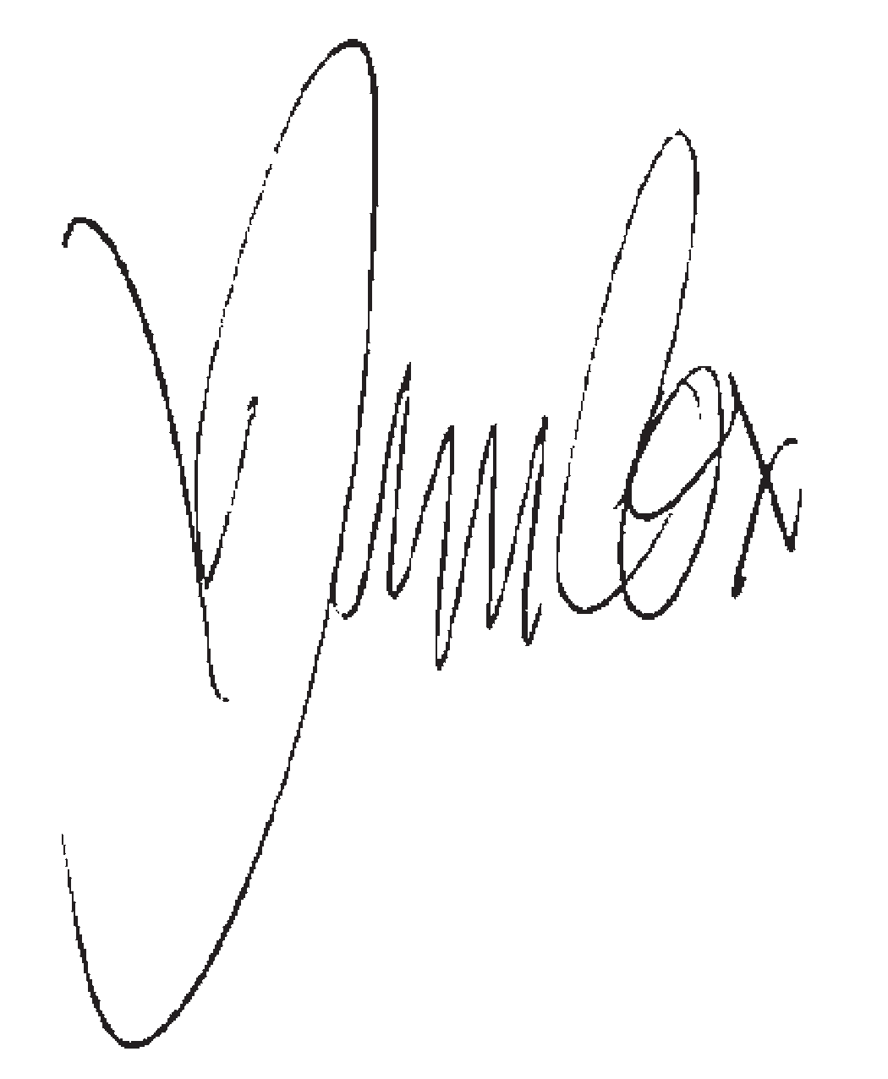
Jim Cox,
Chair, Road Safety Advisory Council

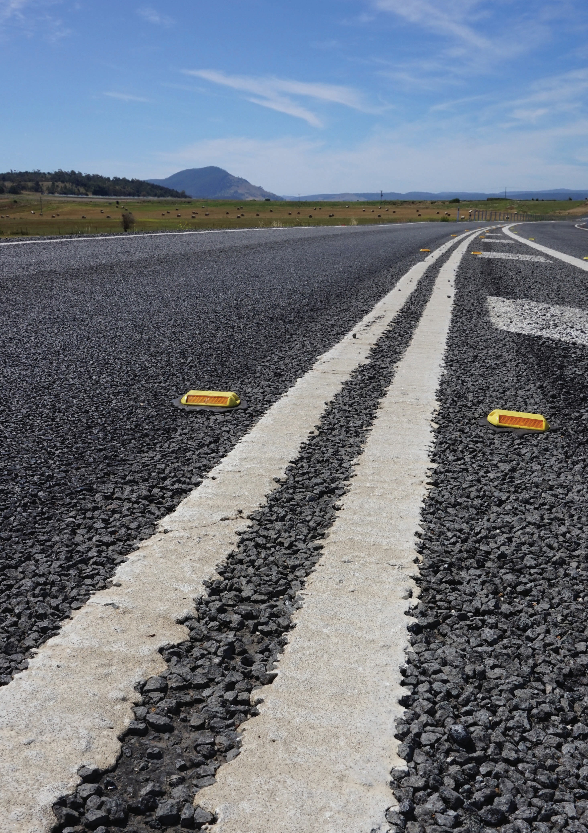

6

Snapshot

Thirteen key directions support the Towards Zero Strategy. The Strategy will work towards reducing the annual number of serious injuries and deaths on Tasmanian roads to fewer than 200 by 2026. The long-term goal for road safety in Tasmania is to have a ‘Safe System’ of zero serious injuries and deaths on our roads and this Strategy will help us on our journey. A Safe System has four essential elements – safe road users, safe roads and roadsides, safe vehicles and safe speeds. Each element plays its part in ensuring the safety of people using our roads.

Key directions

Safe Road Users
- Improve the Graduated Licensing System to reduce serious casualties for 17-25 year olds.
- Introduce safety initiatives to reduce motorcyclist serious casualties.
- Encourage safer road user behaviour through education and enforcement.
- Reduce driver inattention and distraction to reduce serious casualties.

Safe Roads and Roadsides
- Reduce run-off-road and head-on crashes through improved infrastructure.
- Reduce the severity of intersection crashes through improved infrastructure treatments.
- Encourage the latest thinking in safe road design (the Safe System approach).
- Monitor the latest innovations in Safe System infrastructure treatments and trial in Tasmania.
- Reduce serious casualties through improved delineation (e.g. line marking).

Safe Vehicles
- Improve the star rating of Tasmania’s vehicle fleet to include vehicles with better safety features.
- Increase the number of motorcycles with ABS.

Safe Speeds
- Establish speed limits that are more appropriate to the safety features of individual roads.
- Increase enforcement through technology to reduce speed related serious casualty crashes.

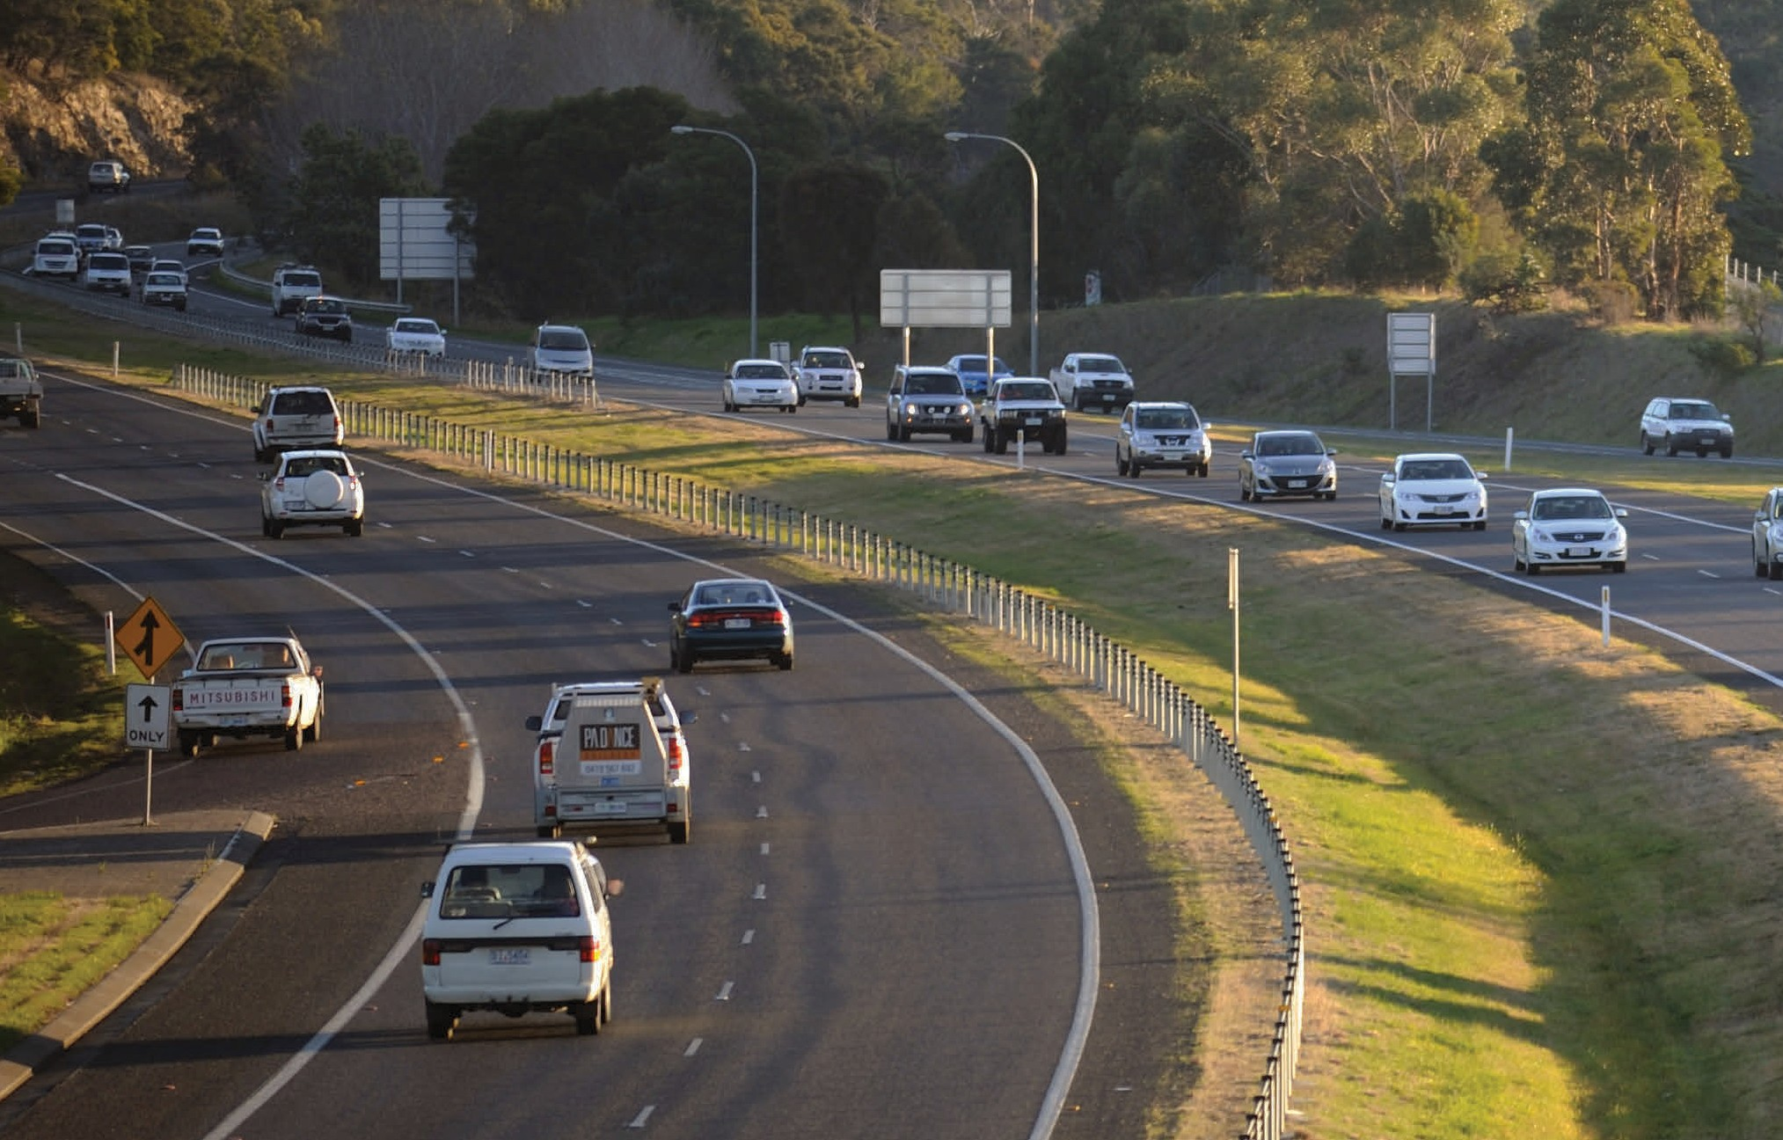Our vision

Driving the Towards Zero – Tasmanian Road Safety Strategy 2017-2026 (Towards Zero Strategy) is the long-term vision of a Tasmania where no one is seriously injured or killed as the result of a crash on our roads.
Achieving this vision will only happen if everyone accepts responsibility for road safety.
We know that our vision will not be easy to achieve and it will not happen overnight. We must continue to take incremental steps, look for innovative solutions, address our crash problem areas and build upon our road safety achievements in order to realise our vision.

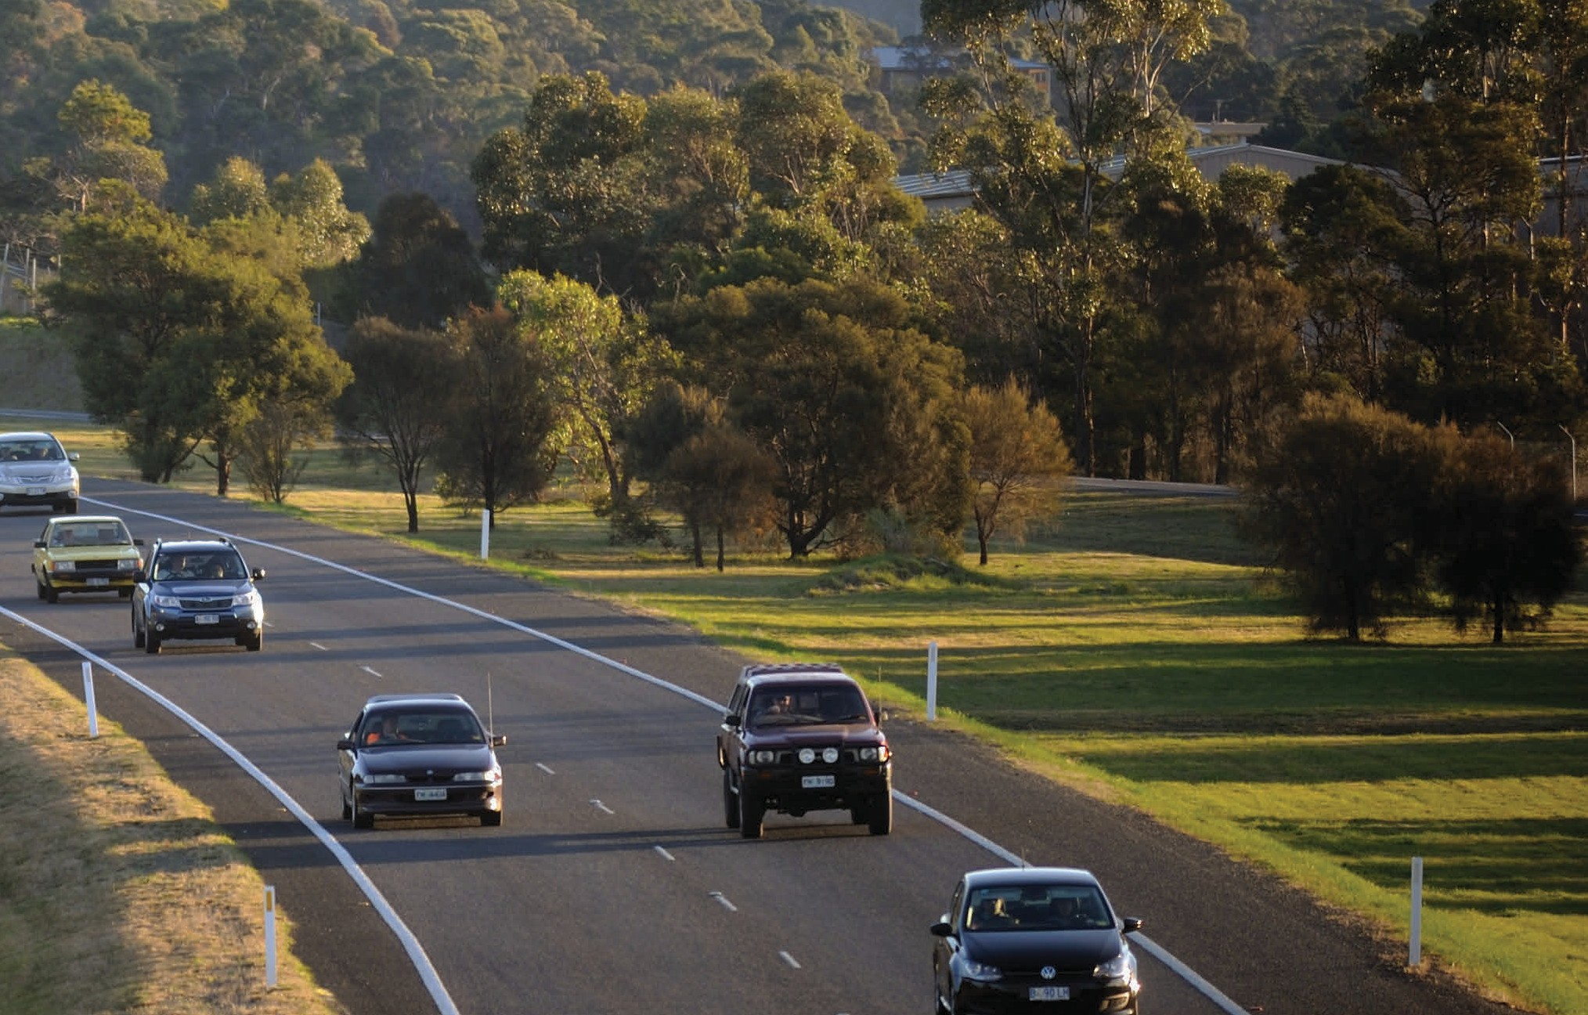Our target

Currently around 300 people are seriously injured and killed on Tasmanian roads each year.
To work towards our long-term vision, the key target for the Towards Zero Strategy is to reduce the number of annual serious injuries and deaths on Tasmanian roads to fewer than 200 by 2026.
We will be working towards reducing the number of serious injuries and deaths on our roads by at least 100 over current levels (annual average). This is deliberately ambitious and we will need to embrace our vision, be guided by this Strategy and implement our Action Plans to accomplish this level of safety improvement.
Fortunately, we’re not starting from scratch. During this time we hope to benefit from the actions taken under the previous road safety strategy including promotion of safer vehicles, improvements to driver licensing for young drivers and increased safety features as part of our standard road design.
The Towards Zero Strategy will focus our road safety efforts over the next decade on 13 key directions to help us reach our short-term target and move closer to our long-term goal of zero.
Regular Action Plans will identify key initiatives under the Strategy to reach our short-term target. For the first Action Plan (2017-2019), these initiatives have been selected based on what we’ve heard from community consultation and recommendations from independent road safety experts. Initiatives that will take longer for the benefits to be realised are to be prioritised and implemented early in the life of the Strategy.
We will review progress towards our target at the end of each Action Plan and use the results to inform our future actions.

Not just a number

Using numbers to talk about serious injuries and road deaths is an easy way to distance ourselves from road trauma, but behind each of those numbers is a person. That person may be somebody you know or love or they may
be a complete stranger, but to somebody else they are very special. Death is forever and it is hard to forget such tragedies. However, it is the hidden cost of road trauma that we often overlook.
Serious injuries cost individuals and those closest to them their wellbeing and happiness. It also has numerous financial implications, all of which can be for life. Others involved in a road crash are also affected. Whether it be an emergency service worker, paramedic, by-stander or the person who caused the crash, their lives change forever as a result of the experience. Each road statistic has a desperately sad story at its core.

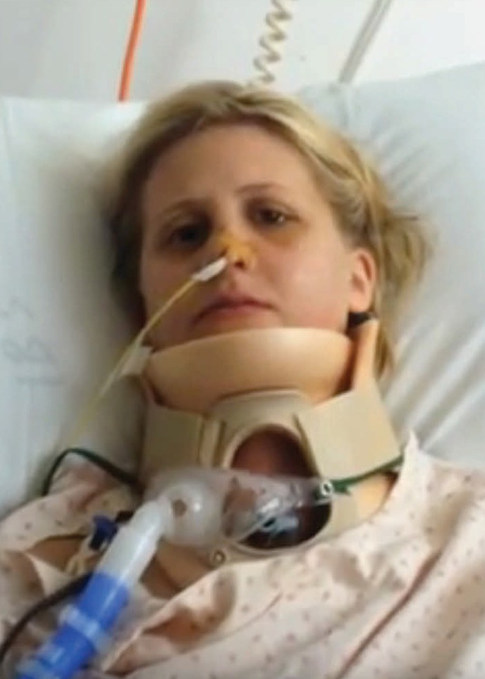

Kirby’s story
“I’d had a really busy day. I was driving home and I fell asleep around a corner. I shattered both of my legs. The car then flipped in the air and the impact of this shattered my face.”
She is still feeling the effects of her injuries. She wants drivers to listen to their bodies and take a rest break when they need to.

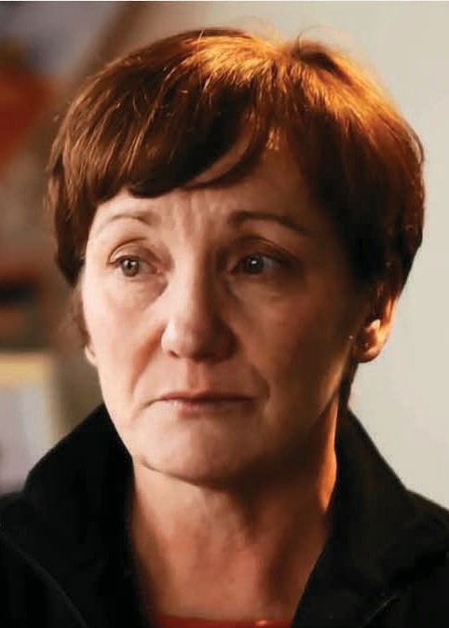

Lisa’s story
“Aaron was the light of my life. He was such a fun-loving boy. The first thing I remember is the policeman saying to my husband Aaron has passed away. He was on his motorbike, he didn’t stand a chance.”
Aaron was killed by two speeding cars racing each other. His mother Lisa’s message: everyone deserves a good life. Just be respectful of other people.

Tasmanian road crashes

Between 2006 and 2015, 3 193 people have been seriously injured or killed from road crashes in Tasmania. Since 2001 there has been a downward trend in the annual number of serious casualties. However, this reduction has clearly plateaued, with around 300 people each year continuing to be seriously injured or killed as a result of crashes on Tasmanian roads.

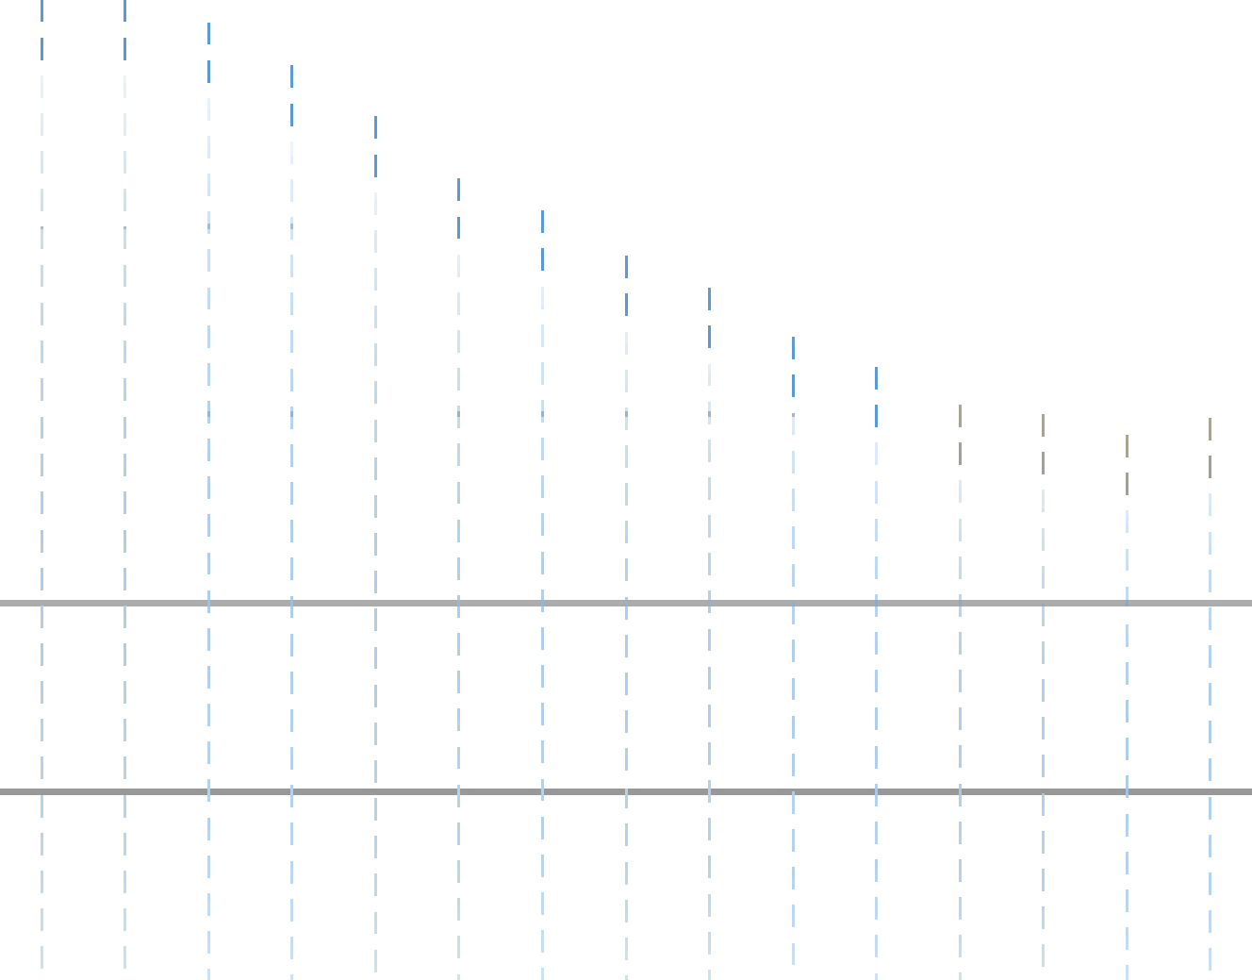
Tasmanian serious casualties (rolling five year averages) 1
600
500
520 520
508
485
458
400
425
408
384
367
341
300
325
330055 300
289
298
200

100

0
2001 2002 2003 2004 2005 2006 2007 2008 2009 2010 2011 2012 2013 2014 2015
Tasmanian Serious Casualties 2 2001-2015.

In terms of annual deaths per 100 000 population in 2013, Tasmania’s rate of 7.02 was higher than the national average (5.13) – with only the Northern Territory having a higher rate. It was also significantly higher than Sweden – a country renowned for its road safety practices – which had the lowest rate (2.72).

Sweden
Australia Tasmania
2.72
5.13
7.02
0 1 2 3 4 5 6 7 8
Road deaths per 100 000 population – OECD countries and Australian states/territories, 2013.

The road safety performance achieved nationally and internationally should provide optimism that improved road safety is indeed possible in Tasmania. Sweden’s road safety record demonstrates that Towards Zero is a realistic vision.

- Each data point represents the average of that year and preceding four years (e.g. 2001 data point is average number of serious casualties for 1997-2001 period).
- A ‘serious casualty’ collectively describes fatalities and serious injuries as the result of a crash. A fatality is where a person dies up to 30 days after the crash. A serious injury involves a person being admitted to hospital for 24 hours or more after the crash.

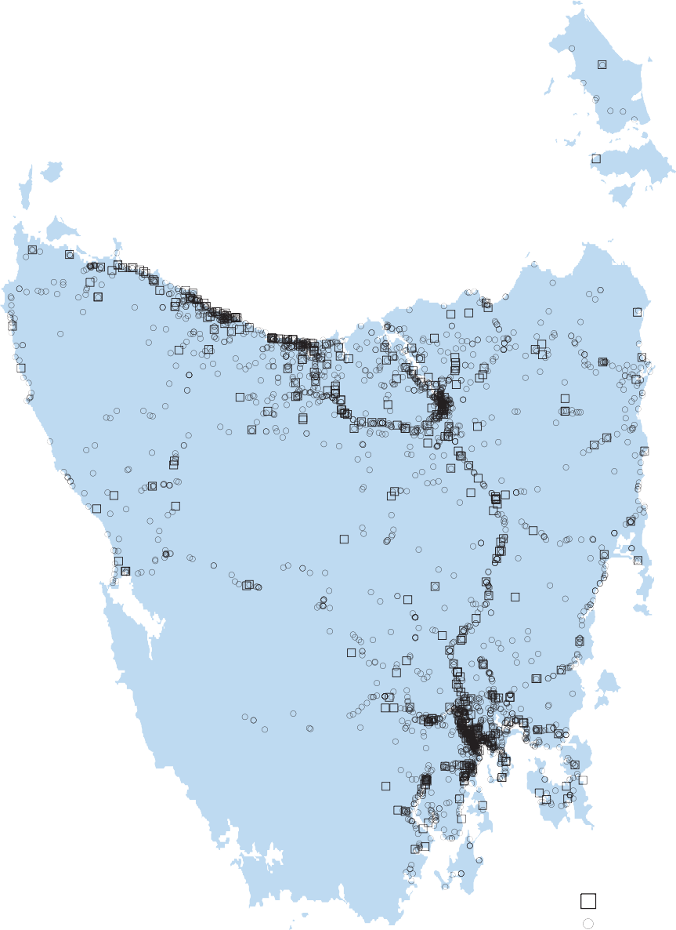!
!
!
!"
!
!!
!!
"
!!!!
! !
!
!
!
! !
"!
!
!!
! !
!

"

"! !
!

"! !
!!!!!"! ""!"!!!"!!" !
!"!

! ! !!!
!!

! !!
!
!! !
"! !
!
!!
! ! "!
"
! !!"!
! !!
"! !!!!!"!!"!
!!"!"!!!
"!"!!
!! !! "!!!!"!!"!!

!!!
!

!
!
!!! ! !
!
"

!
!! !
! ! ""!!!!!!!!!!!!!"!"!"!
!! ! !!!"!!!!!!"!!!
"!! !
! " "
!"!!!
! "!

!!!
"!!
! "! !!!!!!!"!!!!!"!!!!!"!"!"!!!
! ! ! "!
! !!!!!
! !!! ! !

! ! !!!! "!
"! "! !!!
! !!
!
!
!
! ! !

! ! !! !! ! ! !!"!!!!!!!!"!"!!!!"!!!"!!!!! !
!
! ! !!
!!" ! ! !
! !!!
! !! !

! """ !!
!!! !
! !
! ! ! ! ! !

! ! !
! !!! "!!!!!!!!!!!!!!!!
"!! !
! " !! !

" !!!! !!!! "!!! !
! !!
!
!
! !!! !!! ! !
! ! !

""!! "
!!!! ! !

!! "!
!!!!!!!!""! ! "! ! " " ! "

! ! !!!!
! ! ! !"! !! "! !
!" !! !
! ! ! ! !
!!!
!"! !!

! ! ! !!!"!! " " " ! "
!!!! !"!!!" !
!
!
!
!
!
! ! ! !"! !! ! ! !

! ! ! !
!!!!!
!
!"! !!!!! ! ! " !
! ! !"!!! !!

" ! ! !
"
!!!
!! "!!!! !
"!! "! !
! !
! ! !!!
"
"""! !! "!
! !! ! ! !
!
!

! ! " !
" " "! !
! ! !

! ! ! ! ! !
!
! !!!!! " !

! ! !
! !"! ! !
! " !"
"! !! !
!"!

! ! !
! !
! !! !!!"
! ! !!!
!!!
! ! !
!
!!!!!!"!!!!!!!!!!! !
!
!

! ! ! ! "!
"!!"! ! ! !

! !!! !! ""
!!
!
! !!!!!!! !!! ! ! !

!!!!!! " " !
!"!!!!!!!"!!!!!!!

! " ! !""!
!!!!!
! !"!!!!" !

! !!!!
!
!! ! !!
!
! !! !
!" !!!!"!!!!!!!!!!"!!!!!!!!
" !! !

"! ! ! !!
! "!!!!!!!
! !"!!! ! !

! ! !
!
!!!!
!"!"!"! !
"!!!!!"!!! !
! !!!"! !
!!!! !

! !!
"" "
" !!

! !!! "!!!!"!!! !!
! !
!!
!!!! !! ! ! ! !

! " " " "
! !
!!!!!

! ! ! ! !
!!! ! !!! !!!!! !!!!!! ! !! !
! !!

" " "" " "

! ! ! !
! !
!! !!
! !!"!"!!!!!!!
" !
!!
!"!! ! !

! ! ! ! !
! ! " ! "!

"!!!
!
! ! !!
!
! ! "!"!!!
!
!! ! !"!!
!
"" !

! !! "
!
!
! !!
"! "!
!"
!
! ! !

!! !! !!
!!! ! ! !

!
! !"
"
! !
!
!!!"!
"
!!
!! "!"!!
!
! " ! " !!!
! "!
"!!
!
!
!
!!
!
!!!
!! !

!
!
! ! ! " !
!

!
!!!
!
!!!
!
"!!
"
! !!
!
"!!! !!! ! !
!
!"!
!

!!!
!"
!
!
!!!
!! ! !!
!
!! !
! ! ""!
!"! !
!
!
! "!
!!
!
!
!"!

! "!! !! !
!!!
!
!!""!!!!
! !

!
!
!!! !
! !
"! "!!
!
!
! "!! "
!!! !
"
! ! !!
!
!
! "! !
! !
!
!
!!!
! !
!
!
!
!!!
!
!
!
!
!

! ! !
!
! !!
"!!!! !

!! !
! " !! "!
!! ! !
"!!!

" !!

!!
"
!! ! !!
"

!!!
!
"!
!
"!!
!""
!!!"!
! !
! !
! !"! ! !
!!
! !!!
!!!!
"!!!!!!!!
!

!
"! !
! "!!"!
! "!
!!
! !"!!!
!
"! !
! !
"! !

!!! !! !
!!!! !! !!!!""! !

! ! !!"!!!"!"!!!!
!
"!!
!!! !

! !!!
""!!"!!!
!
"!!!!!!!!!!!!!!"!!"! !!! !!!!!!!! ! ! !!

! ! ! !!!!!"
! !
! !
! !!
"
! ! !

" "!" !!
! !
"

! ! ! !!"!!!!!!!!!!"!!!!!!!!
"!!!!!!!!!! !!!
! !!"! !

! "!
""!"!!!!"! !!!!
!"!!!! "! !

! ! !! !!!!!!!!!!!!!"!!!!!! !!" !
!
!

! !!
! !! !
! ""!!!!!!!!!"!!!!!""!!!!!!!!"!
!!" !

"!!! ! ! !

" !!!
! ! ! !!!!! !

""!
" ""! !
! !! "

! ! ! !!!!!!!!!!!!!!!!!!!!!!!!!!!!!!!!!! ! !
!

""" ! !
! !!

" "!!!!! !!
!!!

"!!!!!!!
!! " !
!!!!!!!!!!!!!!"!!!"!!!!!!!!!!!!!!!!!! ! ! !
! " !!
! !!!!!!!!!!!!!!!!! !!!!!!!!!! !!

" !!!!
!!
! ! !

! !!!!!!!!!!!" !!!!!!
!! !!"!!!!
! !
!!!!!! !!"!!!

! !!!"!!""!"!!!!!!
!!!!
!!!"!
!
!"!

" "
!! !!!!
!
"
!! "!"!!

! !!! !!!!!
"!!!!!!! !! !

! !"!!!!!!!
"
! !"!!!!!!!!!!
! !"!
! !!"

" !"!!! !
!!!!
"!!
! !
!"
!
"! !
"
!!
"!
"!!

"!"!!!! !! ! !! !! "!
!!!! !!
!!!!! !!!

! !!!! ! !!
!!! "!!!! "
!!!" ! ! !
! ! !!! ! !
!
!

Serious casualty crash locations 2006-2015.
"!!!!" !
! !
!
!! ! !
!
!

" Fatality
- Serious Injury

Where do fatal and serious injury crashes occur?
A large proportion of serious casualties occur on our higher speed/high traffic volume roads. These are the higher speed feeder roads to our major population centres and suburban connectors. Many serious casualties are also occurring on our higher speed/lower volume rural roads. Less than a quarter of our serious casualties are occurring on lower speed urban roads despite high traffic volumes.
Areas where there have been clusters of crashes have largely been treated. It is important that we are proactive and implement network-wide safety countermeasures and treatments.

What types of crashes are they?
‘Lane departure’ crashes (run-off-road and head-on crashes) account for over two thirds of serious casualties on Tasmanian roads. Strategies to reduce lane departure crashes have the greatest potential to improve road safety in Tasmania.
The most common ‘lane departure’ crash type resulting in serious casualties is run-off-road crashes. Run-
off-road crashes occur when a vehicle veers off the roadway or across the opposing traffic lane. Run-off-road crashes account for almost one in two serious casualties. The severity of this type of crash can be reduced by protecting roadside hazards with safety barriers or removing hazards where practicable. Improved line marking (delineation), including audible edge lines and road edge widening, can help in preventing this type of crash from occurring.
The other form of ‘lane departure’ crash is head-on crashes, which occur when vehicles travelling in opposing directions impact one another head/front on. Head-on crashes have increased and represent around one fifth of serious casualties. Physically separating opposing traffic with median or centerline barrier is an effective method to prevent this crash type. Improved delineation can also help in reducing head-on crashes.
Active vehicle technologies such as electronic stability control, lane departure warning, and autonomous braking systems will increasingly play an important role in preventing lane departure crashes or reducing the severity when a crash of this type occurs.

Crash type 2006-2015

Other
Run off road
Head on

Pedestrian

Lane departure

Almost two thirds of serious casualties occur in higher speed zones (80 km/h or above). However, only around a quarter of all crashes occur on these roads (serious casualty crashes, minor crashes and property only).
Importantly, this helps demonstrate the lower crash survivability when travelling at higher speeds.
At intersections, the potential for crashes is high as road users are required to make more complex decisions and respond to a changing road environment. Intersection crashes account for around one in 10 serious casualties
on Tasmanian roads. Serious casualties from intersection crashes have decreased significantly over the last 10 years, however they still represent around 13 per cent of all serious casualties. Most intersection crashes involve light vehicles, but a significant number of crashes involve pedestrians and a quarter of these crashes involve motorcyclists. Almost a quarter of intersection crashes involve older road users aged over 65. Reductions
in intersection crashes have been achieved through a targeted program of infrastructure treatments such as controlling more intersections with traffic signals, converting intersections to roundabouts, and providing protected left and right hand turn bays. Reduced urban speed limits from 60 to 50 km/h has undoubtedly improved safety at these conflict points.

Who is most at risk?
Drivers and passengers continue to be the road user type most often seriously injured or killed on Tasmanian roads. Improved driver safety can be achieved through a better licensing regime, enforcement, active vehicle technologies, and safer, more ‘crashworthy’ vehicles.

Speed zone 2006-2015

Road user type 2006-2015
Cyclist ATV rider
Driver
Passenger

80 km/h +

50 km/h and under

  - km/h
Pedestrian

Motorcyclist

Vehicle occupant

Motorcycle riders represent more than one in five serious casualties on Tasmanian roads yet motorcycles comprise less than one in 20 of the vehicle fleet. Motorcyclist serious casualties have increased over the last 10 years, from 705 (between 1996 and 2005) to 759 (between 2006 and 2015). Motorcyclists are vulnerable road users as there is little protecting them from injury in the event of a crash. Improved rider training and enforcement will help to improve motorcyclist safety. Active vehicle technologies such as Antilock Braking Systems (ABS) and traction control have a role to play in improving safety for these road users. Protective clothing can also reduce the level of crash injury for motorcyclists.
Pedestrians represent less than one in 10 serious casualties. The number of pedestrians seriously injured or killed on Tasmanian roads has reduced dramatically over the last 30 years. This has been achieved through improving pedestrian safety with more intersections controlled by traffic signals, a continued focus at school crossings, and increased ‘mid-block’ treatments, such as ‘pedestrian islands’ to provide safe crossing points.
Young road users aged 16-25 years continue to be overrepresented in Tasmania’s crash statistics. More than 28 per cent of serious casualties were young road users aged 16-25 years. Improved training for those entering the licensing system, together with licensing restrictions to prevent higher risk behaviours, such as zero blood alcohol concentration, provide opportunities to improve safety for these road users.
Males account for two out of every three serious casualties. A review of the Graduated Licensing System and targeted public education are measures aimed at improving road safety for men.

Gender 2006-2015

Age 2006-2015

Under 16

Female

65+
50-64

16-25

Male

26-49

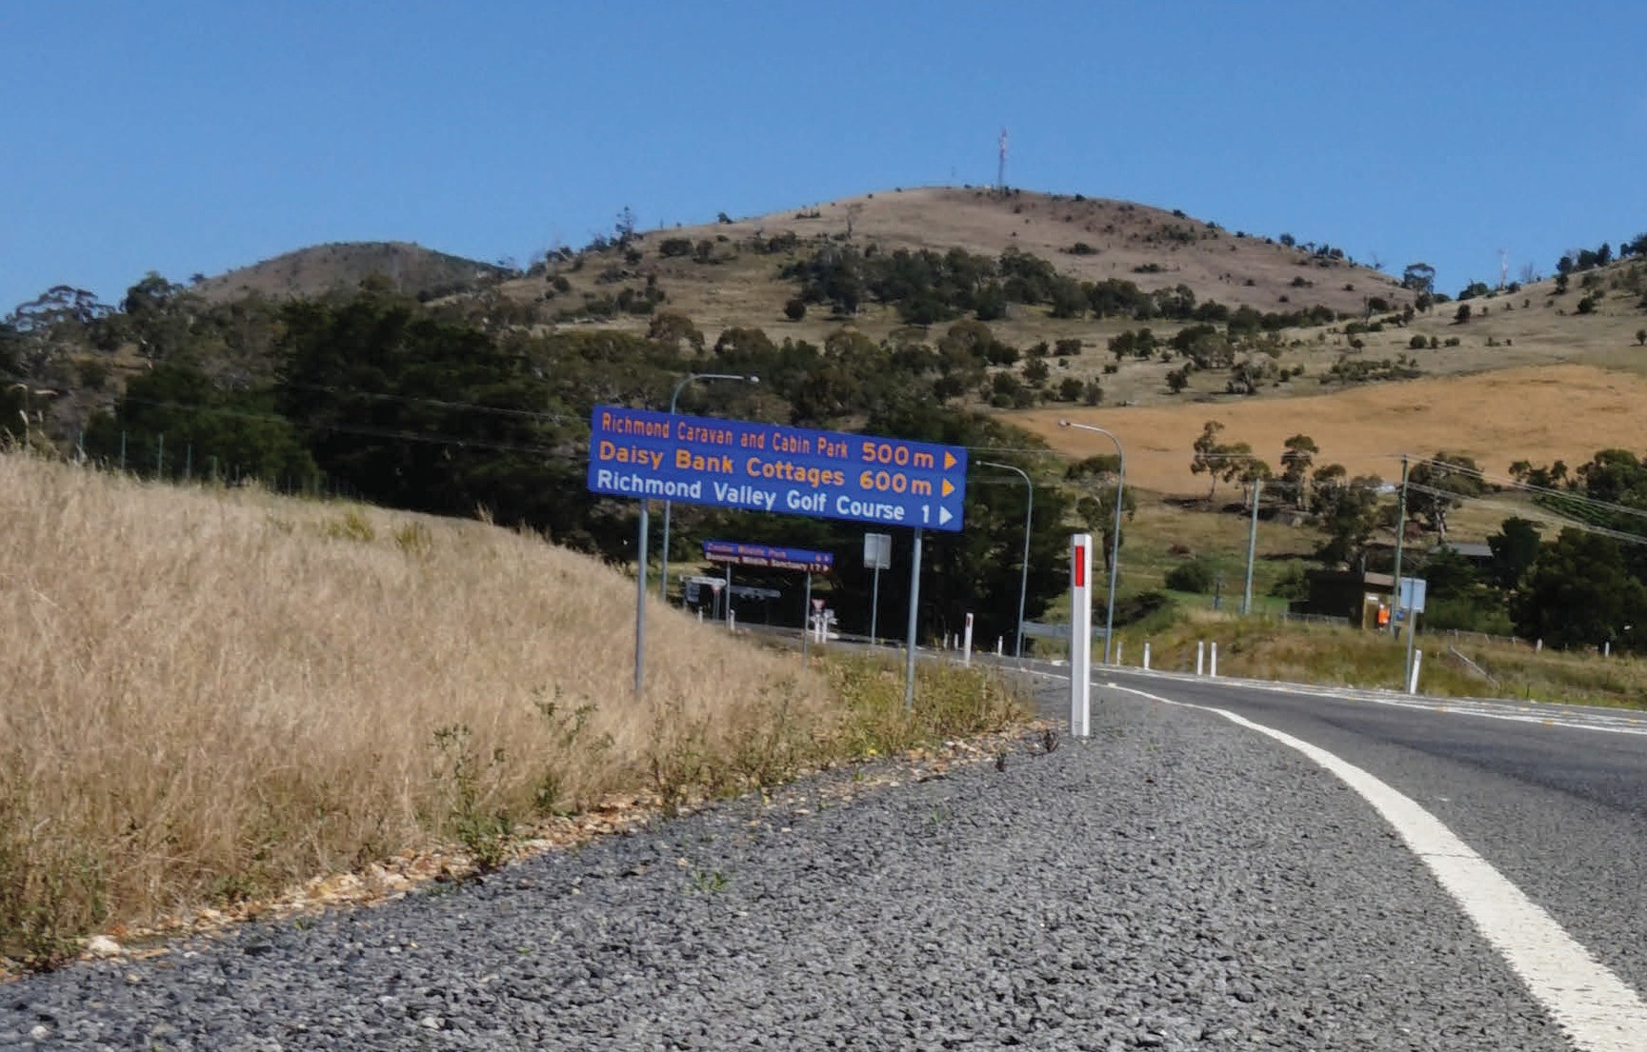What behaviours contribute to serious casualties?
Speed (either excessive speed for the conditions or exceeding the speed limit) is a factor in one in three serious casualties.
Alcohol, inattention, and inexperience continue to be the other leading behavioural factors associated with crashes in Tasmania.
Public and targeted road safety education campaigns clearly have an important role in attracting attention to road safety as an important public health issue. These campaigns promote safe driving and help to make unsafe behaviours, such as drink driving, socially unacceptable in much the same way as anti-cigarette advertising has done to smoking.
Targeted and random enforcement are also fundamental in deterring negligent and illegal road use.
Behaviour is important for road safety. However over two thirds of crashes are not the result of high risk/illegal behaviour but simply the result of unintended mistakes.

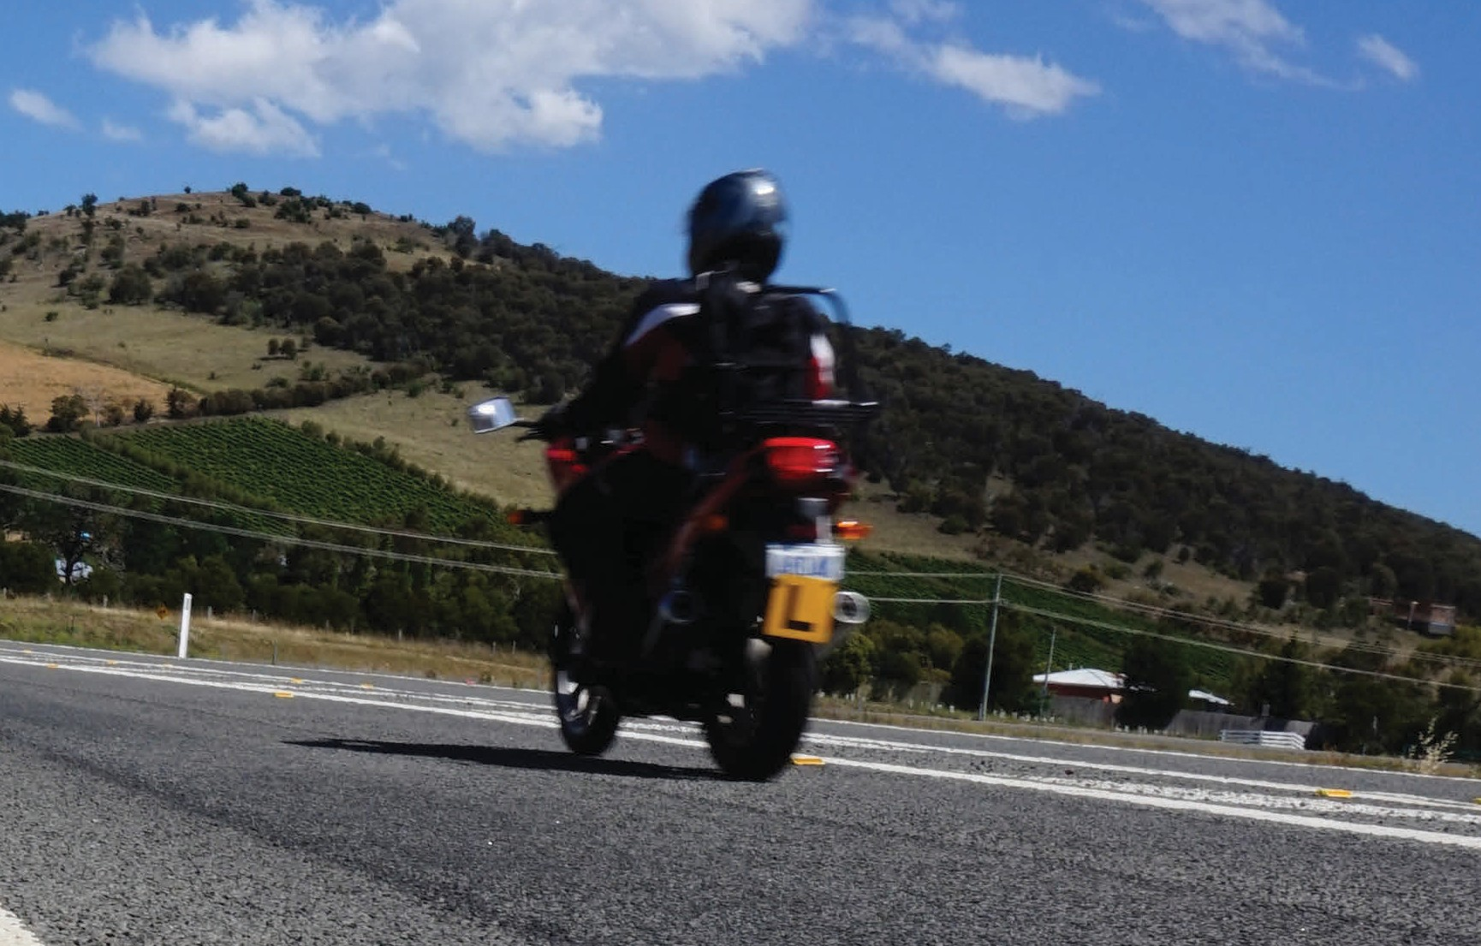

Behaviours contributing to serious casualties | Number of serious casualties | Percentage of serious casualties
Inattention | 829 | 26%
Inexperience | 826 | 26%
Excessive speed for the conditions | 783 | 25%
Alcohol | 685 | 21%
Exceeding the speed limit | 404 | 13%
Behaviours that contributed to serious casualties 2006-2015.

The Safe System approach

Safe System thinking requires us all to accept responsibility for road safety – road and traffic engineers, vehicle designers, manufacturers and marketers, police, educators, trauma managers, as well as each of us as individual road users.
The Safe System approach has been effective in improving road safety and reducing road trauma. Safe System thinking is underpinned by the belief that all road related serious injuries and deaths are preventable and therefore no loss of life is acceptable. We acknowledge that the road system needs to keep us moving, but the system must be designed to protect us.
The key principles of the ‘Safe System’ approach are:
    - We will make mistakes.
    - Our bodies are fragile.
    - We need to create a more forgiving road system.
    - Road safety is everybody’s responsibility.
Human frailty is placed at the centre of the system design, so that mistakes don’t cost lives.

A Safe System has four essential elements which all interact
- Safe Road Users – encouraging safe behaviour through education, enforcement and regulation.
- Safe Roads and Roadsides – designing and maintaining roads to reduce the risk and severity of crashes.
- Safe Speeds – establishing speed limits that are more appropriate to the safety features of individual roads.
- Safe Vehicles – designing vehicles that protect occupants, lessen the likelihood of a crash and simplify the driving task.

In a Safe System, for example, if you are distracted for a split second and veer off the road, audio tactile edge lines may alert you in time to recover. If there is no time to recover, a roadside barrier may prevent you from hitting another vehicle or object. If a collision is imminent, the speed you are travelling and your vehicle safety rating will play a key part in whether you walk away from the scene unharmed or not.
To prevent serious injury and death on our roads, all four elements of the Safe System must work together and continue to be improved. If a crash occurs as a result of a specific weakness of one element, the other three elements either individually or collaboratively should be strong enough to reduce the effects of the crash.

e
r
r
s
v

m

Tasmania’s Safe System approach (adapted from New Zealand’s Safe System approach).

Human tolerance to crash impact

The way forward

Thirteen key directions will guide our road safety efforts over the next decade. These directions align with the four elements of the Safe System approach. While we will continue to focus on a range of road safety issues, the key directions will help us to reach our short-term target of fewer than 200 serious injuries and deaths annually on our roads by 2026 and our long-term goal of zero. Over the next 10 years we will put in place measures to improve road safety and move closer to having a truly Safe System. We know that saving more lives depends on the community’s understanding and acceptance of the Safe System approach and we all need to be committed to this way of thinking to achieve our vision.

Safe Road Users – encouraging safe, compliant behaviour through education, enforcement and regulation.

What we know
When looking at what we can do to improve road safety we tend to focus heavily on the road user and ‘correcting’ behaviours. Educating people about the road rules and safe driving is at the heart of road safety, but on its own it is not enough. Safe driving behaviour is best achieved when complemented by enforcement activities. Education and enforcement will continue to underpin our road safety efforts. However, we know that no matter how well trained or educated we are, we will make mistakes and crashes will continue to occur.
In terms of our road users, young drivers and motorcyclists are the most at risk of being seriously injured or killed in a crash and we need to make these road users our priority.
Research tells us that introducing further changes to our current Graduated Licensing System (GLS) will achieve important reductions in serious crashes involving young drivers. A GLS is designed to protect drivers in the learning stage by requiring them to gain on-road experience in a supervised environment, undertake assessments before they can drive unsupervised and by placing safety restrictions on them that do not apply to other road users. Restrictions are gradually lifted as a learner progresses through the different stages of the
licensing system and they improve their knowledge, driving skills, hazard perception and road craft. An effective GLS does this in a way that reduces the likelihood of young drivers being involved in a serious crash, particularly in the early stages of the provisional driving period when they are most at risk (as shown in the diagram on next page). Currently there are age, speed, and alcohol restrictions on novice drivers in Tasmania. Other jurisdictions have passenger, night-time and vehicle power-to-weight ratio restrictions.
In terms of motorcycles, we know that their numbers on our roads have increased steadily over the last
10 years. Although they only account for 4 per cent of all registered vehicles, motorcycle crashes account for over 22 per cent of serious casualties. Motorcyclists are extremely vulnerable in the road environment as there is very little protecting them from injury when something goes wrong. There is no ‘silver bullet’ for improving the safety of motorcyclists on our roads but it is an area where we must identify actions to benefit these road users.

Source: Austroads (2008), The Crash and Offence Experience of Newly Licensed Young Drivers, Sydney, AP-R331/08.
Year 1
Year 2

What we’ve heard
Road safety education and enforcement activities are strongly supported in the community, as is improving the safety of motorcyclists through increased education and targeted campaigns.
Making changes to the current licensing requirements for learners and provisional drivers (GLS) is also supported. However, there is greater support for improving young driver training than for introducing any further licensing restrictions, such as passenger and night-time driving restrictions.

What we’re going to do
Current levels of road safety education and enforcement on our roads will continue. For motorcyclists, we will direct our efforts toward improving training, promoting the benefits of protective clothing and encouraging safe riding practice. More generally, we will also concentrate on promoting safe road user behaviours and raise awareness about the dangers of inattention and distraction.
We need to build on education and enforcement activity to improve safety for road users. Our future drivers need to understand their responsibility for road safety and commit to safe driving practices from a young age. That is why we will be strengthening our GLS. The number of serious casualty savings we can expect from improving the GLS reduces if we only make changes to the training and assessment elements. We need to introduce a number of restrictive elements even though there is mixed support for doing this. It will be important that we continue to work with our community to inform and create a better understanding of the road safety benefits to all from making further improvements to our GLS.

Our key directions for safe road users are:
- improve the Graduated Licensing System to reduce serious casualties for 17-25 year olds
- introduce safety initiatives to reduce motorcyclist serious casualties
- encourage safer road user behaviour through education and enforcement
- reduce driver inattention and distraction to reduce serious casualties.

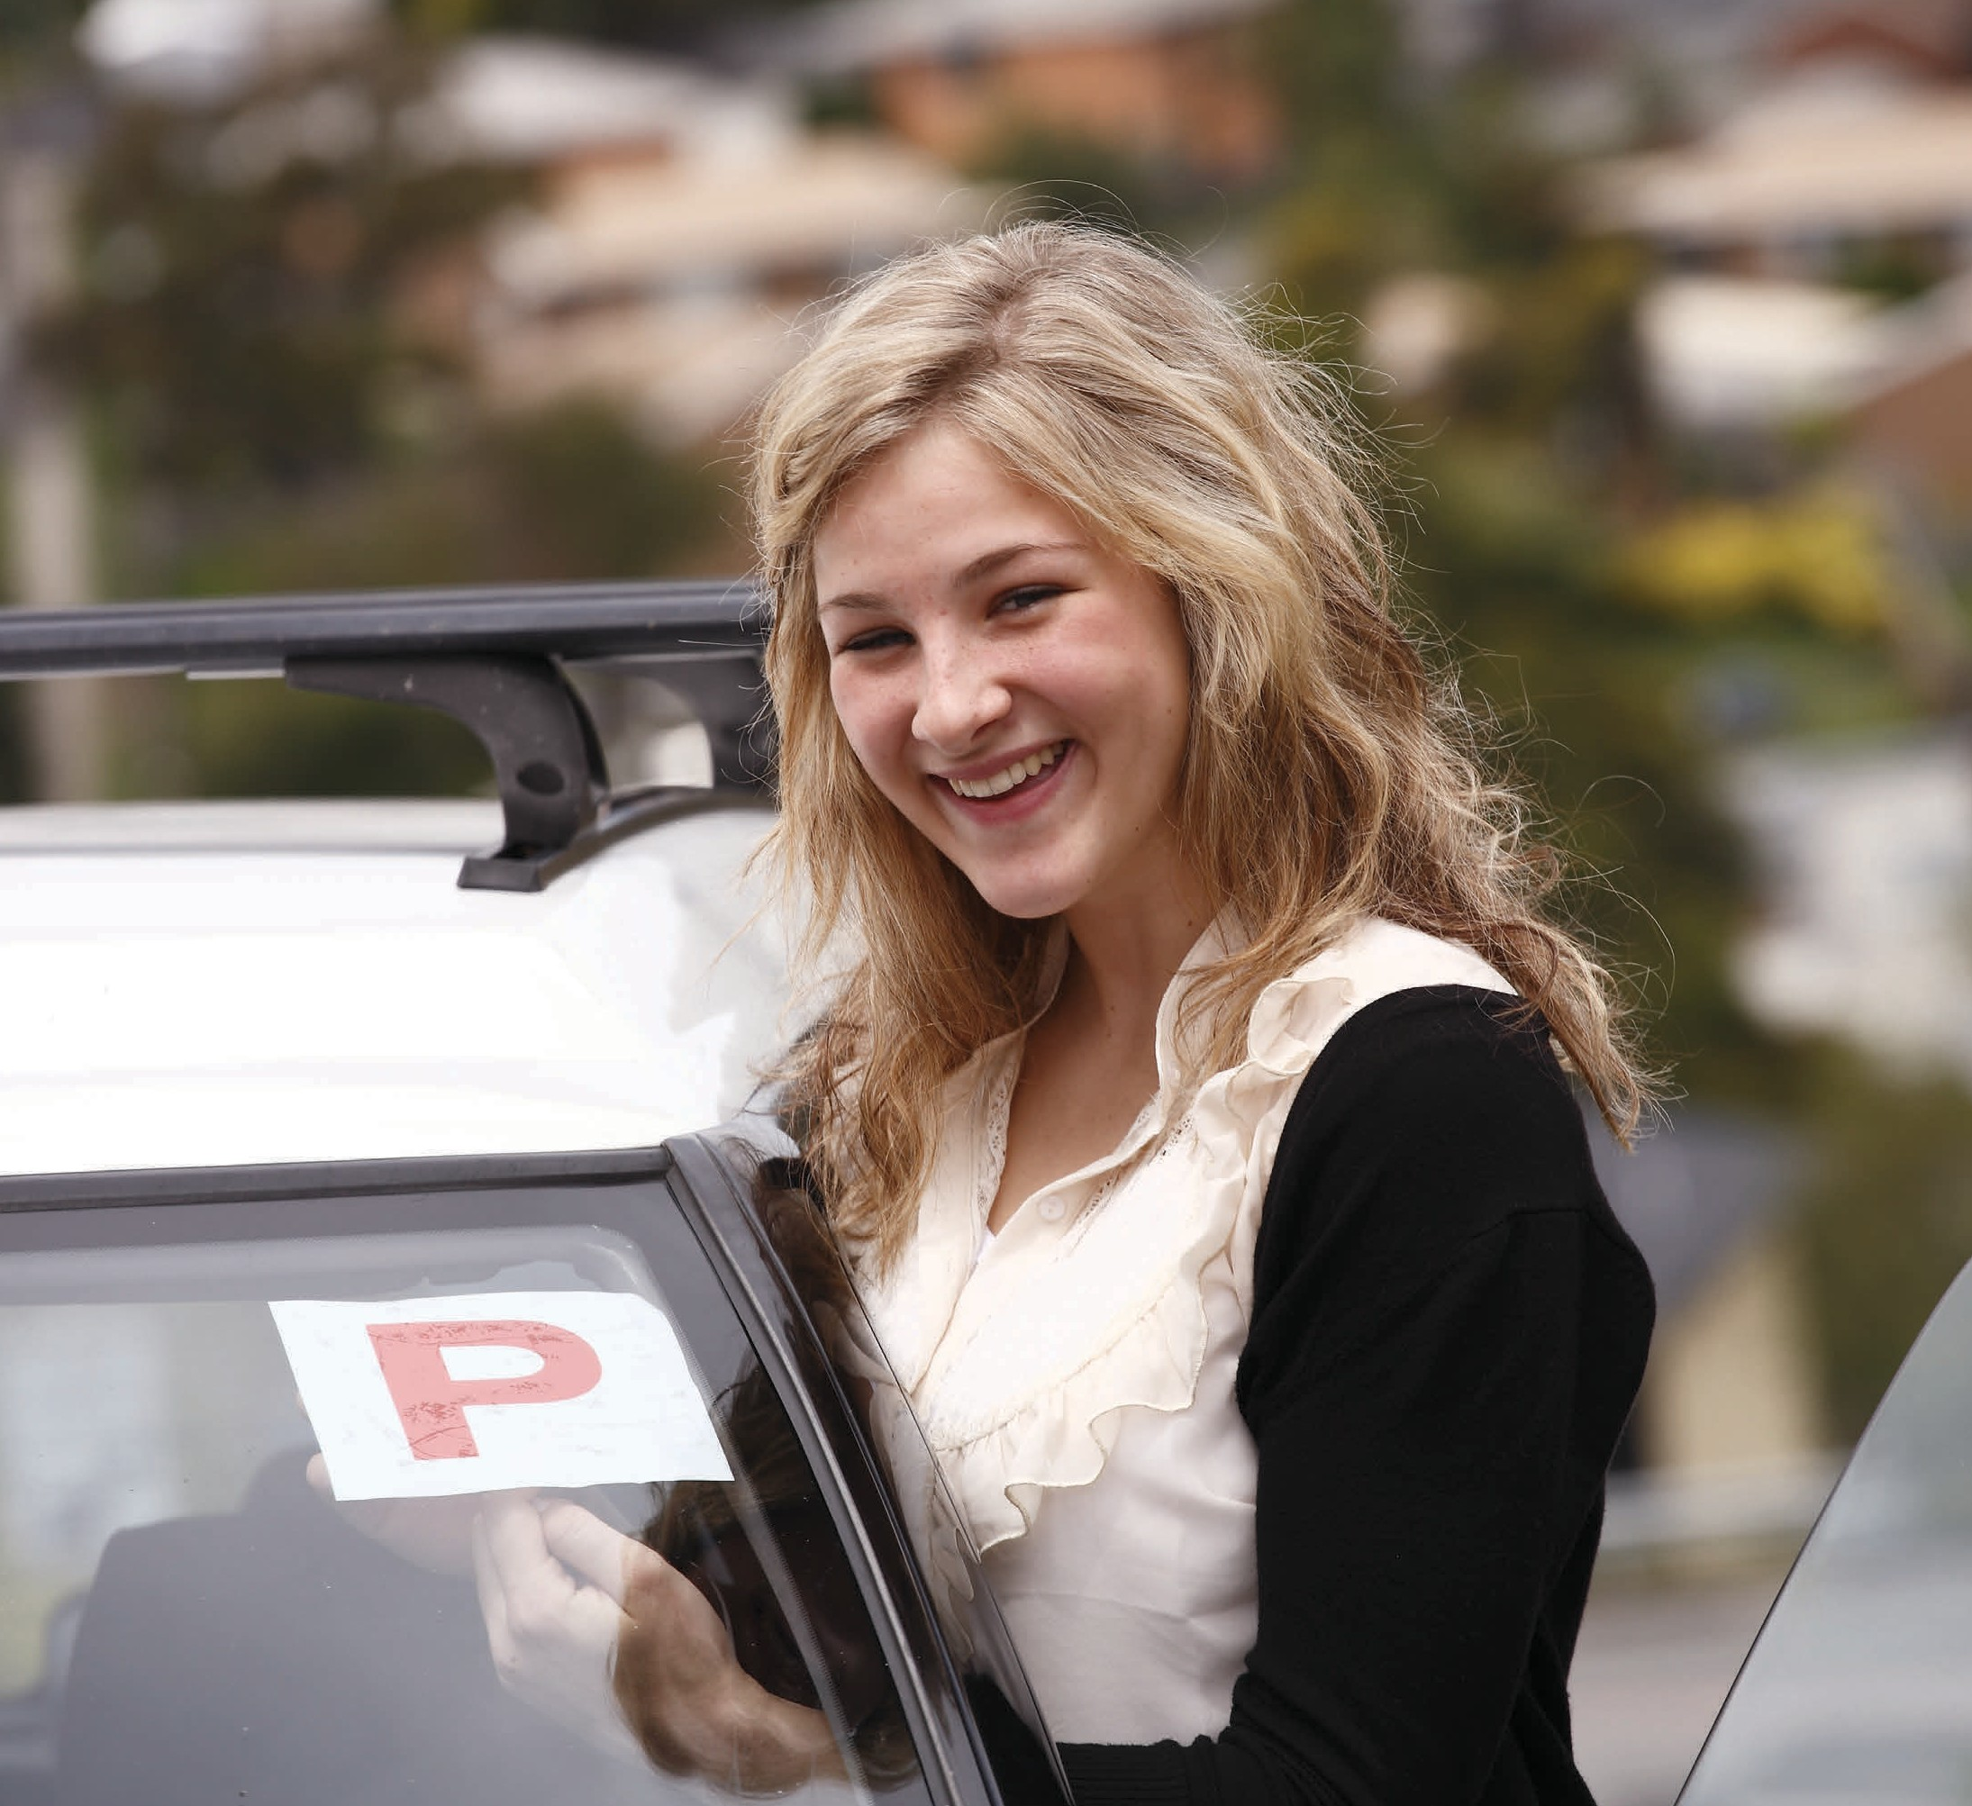
Young drivers are most at risk of being involved in a crash in the early stages of the provisional period

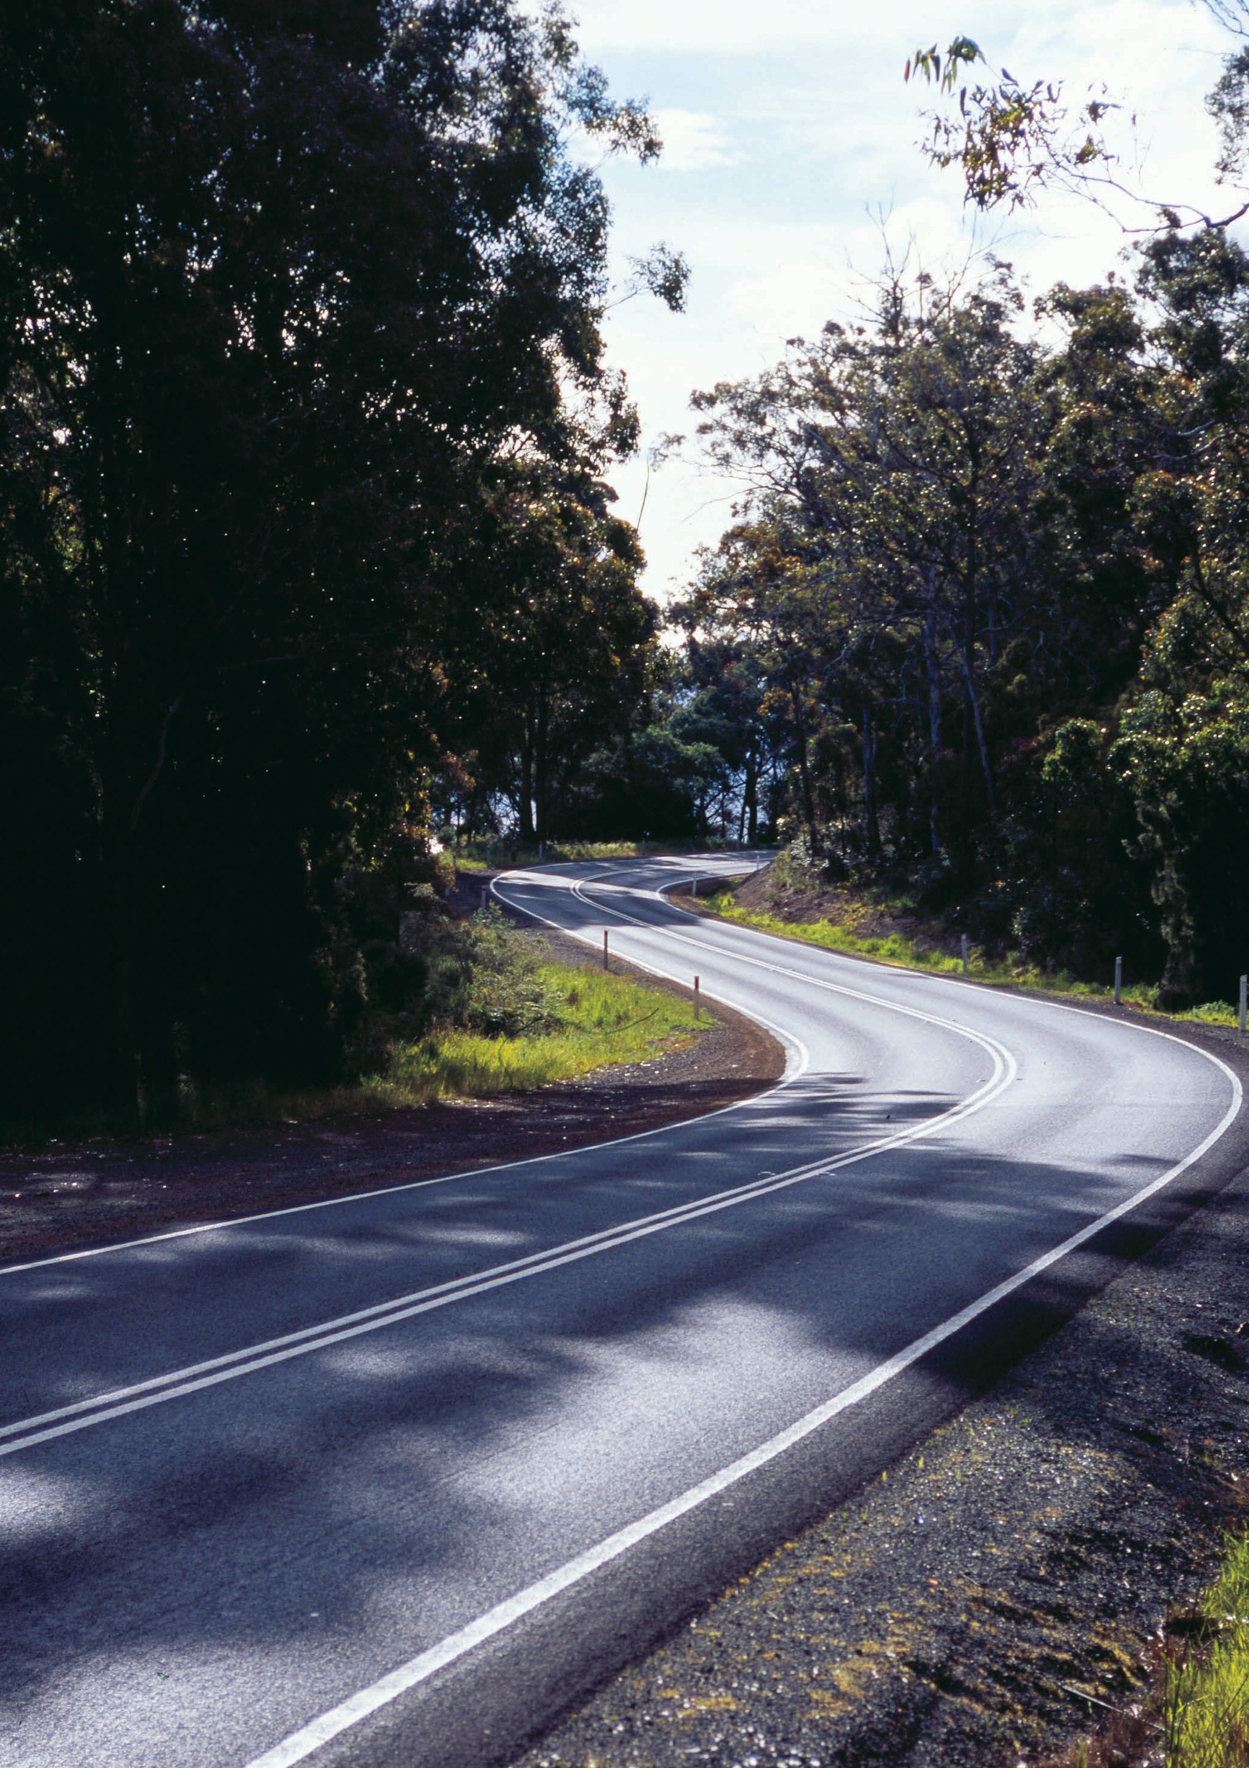

23

Safe Roads and Roadsides – designing and maintaining roads to reduce the risk and severity of crashes.

What we know
Tasmania has a network of more than 18 000 kms of roads. Many of these roads are higher speed rural roads that are narrow, winding and hilly. They are missing important safety features such as line marking, sealed shoulders and clear zones on the roadsides.
Significant investment is required to improve the safety standard of Tasmanian roads. We know that the infrastructure required to keep people safe and minimise risk on our roads is costly, but this is justified by the number of serious injuries prevented and lives saved. We can work towards increasing the level of safety by ensuring we are guided by best practice in road design, retrofitting safety features on existing lengths of road, and using evidence to target our most unsafe roads. It is extremely important that we focus our efforts on this aspect of the Safe System, as we know it is best practice infrastructure that provides ongoing benefits and an environment which is forgiving of human error.
In a Safe System, opposing traffic is physically separated by the use of median barrier such as 2+1 and 2+2 road configurations, or separated dual carriageway to eliminate the risk of head-on crashes. Similarly, roadside hazards are protected with barrier to eliminate the risk of run-off-road occurrences resulting in road trauma crashes. Retrofitting these safety treatments in the road network is expensive and cannot be achieved overnight. Increasingly, our high speed 110 km/h network is being enhanced with these safety features. By 2025, the Midland Highway will have median barrier for much of its length and will also have extensive lengths of side barrier. On other parts of the network we only have the resources
to use these safety treatments as a targeted measure on the higher risk, higher volume roads. Less costly infrastructure can also deliver positive road safety outcomes by minimising road user risk. This includes sealing road shoulders, removing roadside hazards or protecting them with barriers, improved delineation and audible edge line markings.

What we’ve heard
Many lower-cost infrastructure treatments like audible edge line markings and sealed road shoulders are strongly supported by the community as ways of reducing head-on and run-off-road crashes. Support for these treatments shows a shared understanding of the risk and seriousness of these crash types and how even simple infrastructure treatments can improve safety.
In terms of reducing side impact crashes, we know that there is little support for safety measures such as eliminating right hand turns or introducing raised ‘plateaus’ at intersections that will either eliminate or reduce the risk of crashes at these conflict points. However, there is support for roundabouts. Roundabouts are a proven safety measure because they reduce speed, protect opposing traffic and reduce the potential for dangerous side impact crashes so that when crashes do occur at these locations the risk of serious injury and death is significantly reduced. Community feedback also indicates there is some confusion about using roundabouts. Ongoing education about the rules for using them will ensure proper use and continued safety benefit.

What we’re going to do
Our two biggest challenges for making our roads and roadsides safer are managing road lane departures and collisions at intersections. We can significantly reduce the likelihood of lane departures occurring by installing continuous lengths of flexible safety barrier on the road network. This is a relatively expensive treatment. Nevertheless it is being adopted as the standard for our 110 km/h network and will also be installed at higher risk locations around the state.

Our key directions for safe roads and roadsides are:
- reduce run-off-road and head-on crashes through improved infrastructure
- reduce the severity of intersection crashes through improved infrastructure treatments
- encourage the latest thinking in safe road design (the Safe System approach)
- monitor the latest innovations in Safe System infrastructure treatments and trial in Tasmania
- reduce serious casualties through improved delineation (e.g. line marking).

Delineation and line markings minimise lane departures. Innovative vehicle technologies also use line markings to avoid crashes. We will improve the quality of delineation and line marking on our road network.
We will work towards eliminating points of conflict and minimising opportunities for side impacts at high risk locations across our road network. We will trial a range of lower-cost Safe System infrastructure on a case-by-case basis and as part of larger demonstration projects.
Where best practice infrastructure improvements cannot be achieved, we will manage speeds to increase the likelihood of survival in the event of a crash. Working with our road designers to improve knowledge of the Safe System and implementing innovative safety solutions will facilitate the construction and management of safer roads.

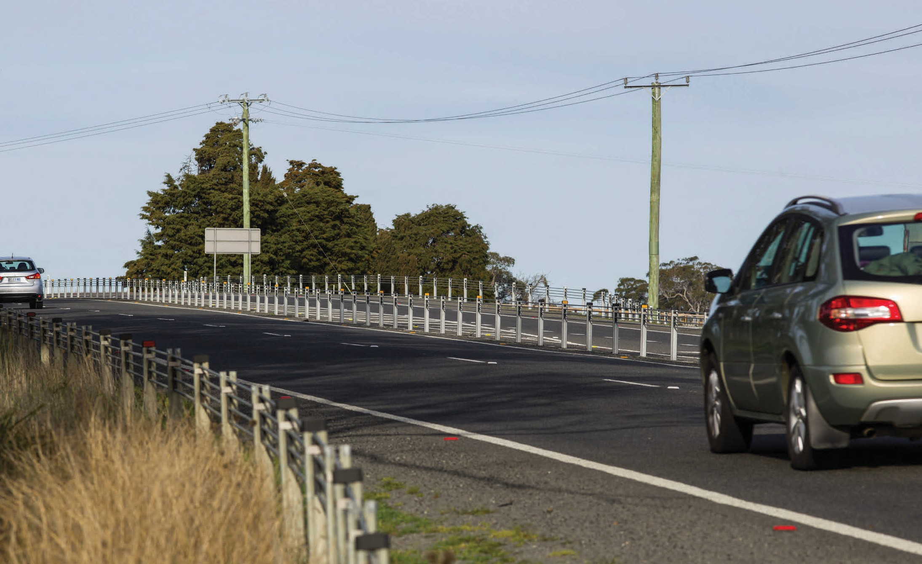
Flexible safety barriers provide full separation between vehicles travelling in opposing directions.

Safe Vehicles – designing vehicles that protect occupants, lessen the likelihood of a crash and simplify the driving task.

What we know
Tasmania has the oldest vehicle fleet in the country, with an average age of 12 years. Vehicle safety has been improving at a rapid rate over the past decade. The ability for the vehicle structure to protect occupants in a collision (passive safety) has improved dramatically over time and attention has now turned to technologies
that are capable of avoiding crashes altogether (active safety). With a relatively old vehicle fleet we know many people are not benefiting from the improved safety features of new vehicles.
It is important to get as many 5 star vehicles as possible into the Tasmanian vehicle fleet to accelerate the introduction of safety features found in modern 5 star cars. Every year that a new vehicle or safety technology is delayed from entering the fleet results in a diminished safety effect in future years. This is because it takes many years for the vehicle fleet to turn over. If a new safety technology is introduced tomorrow, it will take approximately 20 years before it penetrates the entire fleet 3. If everybody drove the safest vehicle available serious casualties could be reduced by 26 per cent 4.
We also need to increase the safety features on motorcycles as motorcyclists continue to be over-represented in serious casualty crashes. Research tells us that ABS for motorcycles have significant safety benefits and have been shown to reduce serious casualties by up to 39 per cent 5.

What we’ve heard
Understandably, concerns have been raised about the affordability of initiatives to accelerate the uptake of new vehicles. We have taken this into consideration but we also recognise the significant reductions in serious casualties that can be gained from addressing issues with the safety of vehicles currently on Tasmanian roads. There is also a level of misunderstanding about ‘roadworthiness’ and ‘crashworthiness’. It is important that vehicles are properly maintained and kept ‘roadworthy’. However, the performance of a vehicle in a crash will relate to its inbuilt safety features such as air bags and its physical structure and less so to its roadworthy status, such as a failed headlight. Increasingly ‘active safety’ features like autonomous emergency braking and lane departure warning will help prevent crashes from occurring.

What we’re going to do
Through public education we will continue to actively promote the value of buying the safest vehicle that you can afford. We will also continue to support the work of the Australian New Car Assessment Program (ANCAP).
The Tasmanian Government needs to be proactive in ensuring that safer vehicles are more widely available. As the largest vehicle fleet managers in Tasmania, the Tasmanian Government must take the lead in purchasing 5 star vehicles. This will increase the availability and affordability of safer vehicles as they are resold into the community.
Actions to encourage the purchase of ABS equipped motorcycles will also be pursued.

- Mackenzie, J., Wooley. J., Stokes. C., Kloeden., Raftery., S. (2016). Analysis and modelling of crashes in Tasmania. (CASR136). Centre for Automotive Research. Adelaide.
- Newstead, S., Delaney, A., Watson, L., Cameron, M. (2004). A model for considering the “total safety” of the light passenger vehicle fleet. Monash University Accident Research Centre. Report No. 228.
- Fildes, B., Newstead, S., Rizzi, M., Fitzharris, M., Budd, L. (2015) Evaluation of The Effectiveness of Anti-Lock Braking Systems on Motorcycle Safety in Australia, Monash University Accident Research Centre Report No. 327.

Our key directions for safe vehicles are:
- improve the star rating of Tasmania’s vehicle fleet to include vehicles with better safety features
- increase the number of motorcycles with ABS.

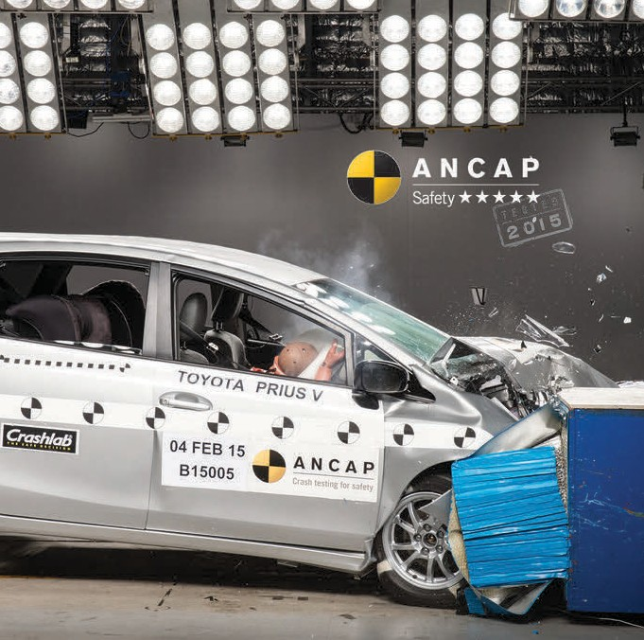
A 5 star rated vehicle provides a greater level of occupant protection in a crash than a lower rated vehicle (Image source: ANCAP).

Safe Speeds – establish speed limits that are more appropriate to the safety features of individual roads.

What we know
The higher the travel speed, the greater the chance of being involved in a crash and the more severe the consequences will be if a crash occurs. Safe travel speed is a fundamental cornerstone of the Safe System approach. Speed limits need to be set at appropriate levels and road users need to travel at speeds that are suitable for the conditions. Some speed limits may currently be set at a higher level than our bodies can tolerate should a crash occur. This can result in serious injury or death.
Under a Safe System, speed limits are set at survivable levels that are appropriate for the level of protection provided by safety infrastructure on a particular road or section of road.
It is important that road speed limits reflect the safety features of the road to reduce the risk of road trauma resulting from a crash. Admittedly, lower travel speeds will have a moderate impact on travel times but this is a very small price to pay for the significant reduction in serious injury and death on our roads. Research tells us that even small reductions (10 km/h) in travelling speeds can lead to reductions of 25 per cent in serious casualties across the road network 6.

What we’ve heard
It is widely acknowledged that speed is a major factor in road crashes, but we generally associate speeding with ‘bad drivers’. We know that the community does not currently support reduced blanket speed limits on our roads. However, there is support for targeted improved speed management on individual roads. This is a step towards a Safe System.

What we’re going to do
We will continue to focus on penalising road users that put others at risk by speeding on our roads. We will look to use new, more effective speed camera technologies and ensure all cameras are operated in a manner that maximises safety.
A key focus will be working on changing our collective attitude to driving to the road conditions including the acceptance of the need to moderate speed to the safety features of the road. We have a natural fear of heights but lack the ability to perceive the inherent danger of horizontal travel speeds. As pedestrians, we happily stand centimetres away from vehicles whizzing past at 50 or 60 km/h. As car drivers, we feel perfectly safe as we drive at 100 km/h with oncoming vehicles
and trucks flying past us at similar speeds. Should something go wrong in either scenario, serious injury or death is almost certain. We know changing our attitude toward speed will be a challenge and will require a number of actions to change our perception of the risks of using our roads.
A combination of approaches can help us achieve safer speeds. This could include public education, enforcement, policy changes, and reviewing individual roads to assess whether current speed limits are appropriate for the level of safety features provided. However, it is crucial in moving towards a Safe System that we all have a greater understanding of the speeds the human body can tolerate in a crash situation.
We will work towards sensible speed limits based on infrastructure standards and safety features, and have fewer speed zone changes. We will also encourage compliance with speed limits through the use of new and additional enforcement technologies.

- Mackenzie, J., Kloden, C., & Hutchinson, T. (2015). Reductions of speed limit from 110 km/h to 100 km/h on certain roads in South Australia: a follow up evaluation (CASR115). Centre for Automotive Research. Adelaide.

Our key directions for safe speeds are:
- establish speed limits that are more appropriate to the safety features of individual roads.
- increase enforcement through technology to reduce speed related serious casualty crashes.

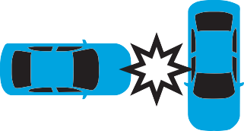
Crash type
Impact speed
Head-on
70 km/h
Side-impact
50 km/h
Side-impact with
fixed object
30 km/h
Pedestrian
30 km/h

International research shows the maximum survivable impact speeds above which the chances of serious injury and death are more likely.
We must use a combination of safer vehicles with better safety features, safer infrastructure treatments, and more appropriate speed limits to reduce conflict points between road users and protect people from the impact of crashes.

Working Towards Zero

Actions Plans will support the implementation of initiatives under the key directions of the Strategy. The results of community consultation and recommendations from independent road safety experts at the Centre for Automotive Safety Research (CASR) have informed the selection of initiatives under the Towards Zero Action Plan 2017-2019 (Action Plan 2017-2019).
Three Action Plans will cover the 10 year period of the Strategy and will be for three years, three years and four years respectively.
  - Action Plan 2017-2019
  - Action Plan 2020-2022
  - Action Plan 2023-2026
The Government will be monitoring our progress towards implementing the initiatives outlined in our Action Plans through quarterly reporting by the Road Safety Advisory Council. Towards the end of each three year Action Plan we will use this and our crash data to review progress towards our short-term target.
This information will be essential in determining the initiatives under the Action Plan for the following period.

Glossary of terms

‘2+1’ configuration | A three-lane road with the provision of alternating lanes and a flexible safety barrier located in the narrow median.*
‘2+2’ configuration | A four-lane road with a flexible safety barrier located in the narrow median.*
Audio tactile line markings | Raised or specifically textured strips typically installed on the edge line (or in some cases centreline), generating noise and vibrations through vehicles in order to alert drivers that they are leaving their lane, and encouraging them to return to their lane. ‡
Centreline barrier | A device used on multilane roads to keep opposing traffic in prescribed carriageways. ‡
Delineation | Treatments that enhance the selection of the appropriate path and speed, or position, to allow a manoeuvre to be carried out safely and efficiently, e.g. line marking, raised pavement markers, traffic cones and flaps and post-mounted reflectors. ‡
Fatality | Where a person was killed before a report was made by Tasmania Police or died up to 30 days after the crash.
Flexible safety barrier | A road safety barrier system consisting of wire rope cables under high tension that are supported on posts and anchored at the ends. ‡
Motorcycle Antilock Braking System (ABS) | System which prevents the wheels from locking up by automatically modulating the brake pressure when the rider brakes hard. By preventing the wheels from locking, the system aids riders to maintain steering control which may reduce stopping distances in certain situations.†
Safe System | The ‘Safe System’ approach works to improve road safety and eliminate road trauma. A Safe System has four essential elements which all interact, including safe road users,  safe roads and roadsides, safe vehicles and safe speeds. This approach is underpinned by the beliefs that road safety is everybody’s responsibility, people will make mistakes and the human body is fragile. Human frailty is placed at the centre of the system design, so that mistakes don’t cost lives.
Sealed shoulder | The sealed edge of roads outside of the travelled carriageway (the shoulder) of roads. Sometimes it is delineated by an edge line applied between the sealed shoulder and the travelled section of a carriageway. The treatment is almost invariably associated with unkerbed roads, and is often applicable to rural roads.‡
Serious casualties | Include fatalities and serious injuries.
Serious injury | Where a person was admitted to hospital for 24 hours or more.
Wide centrelines (painted median) | Two parallel painted centrelines, often with audio tactile surfaces, which provide separation of opposing traffic.*

* Jurewicz, C., Aumann, P., Bradshaw, C., Beesley, R., Lim, A. (2015). Road Geometry Study for Improved Rural Safety. Austroads Ltd. Sydney.
† OECD and ITF. (2015). Improving Safety for Motorcycle, Scooter and Moped Riders. OECD Publishing. Paris.
‡ Austroads (2015). Glossary of Terms (2015 Edition). Austroads Ltd. Sydney.

31

Department of State Growth Road Safety Branch
Towards Zero – Tasmanian Road Safety Strategy 2017-2026
GPO Box 536
Hobart TAS 7001 Australia
Phone: 03 6166 3239
Email: towardszero@stategrowth.tas.gov.au Web: www.towardszero.tas.gov.au

© State of Tasmania December 2016

