Fewer than 200 serious injuries and deaths on our roads by 2026

Towards Zero
Action Plan 2017-2019

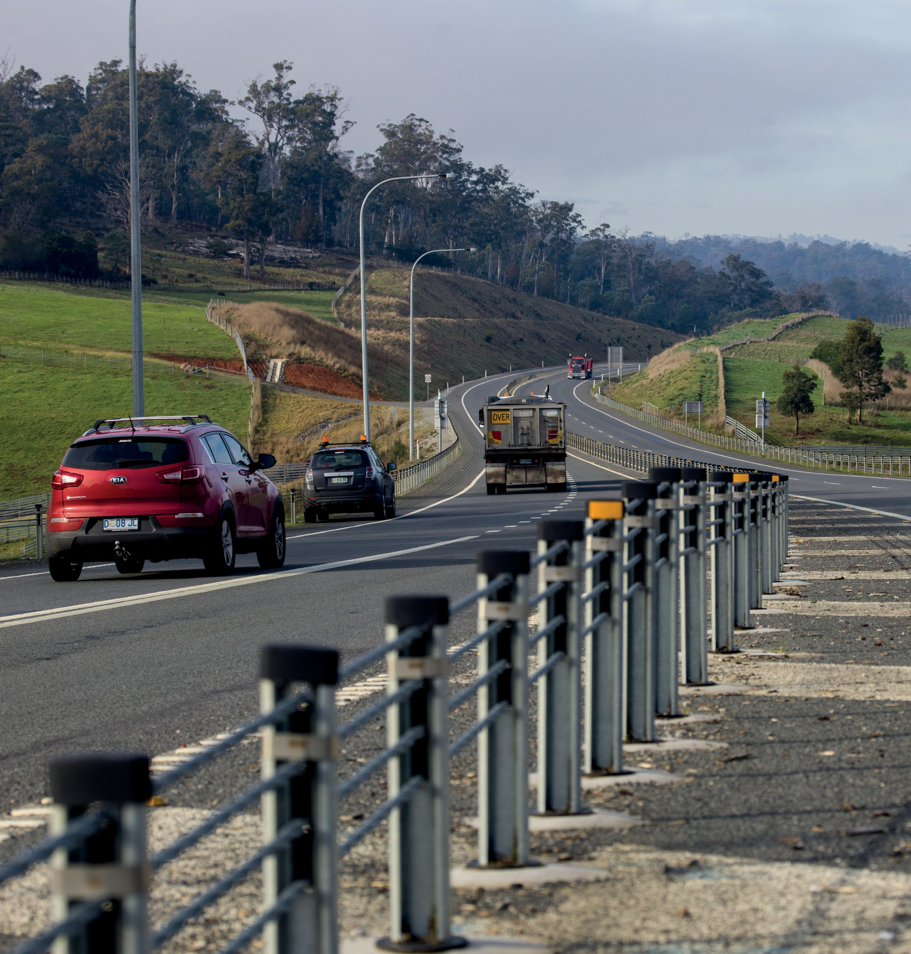Department of State Growth

Copyright notice and disclaimer
Copyright in this publication is owned by the Crown in Right of Tasmania, represented by the Department of State Growth.
Information in this publication is intended for general information only and does not constitute professional advice and should not be relied upon as such. No representation or warranty is made as to the accuracy, reliability or completeness of any information in this publication. Readers should make their own enquiries and seek independent professional advice before acting on or relying upon any of the information provided.
The Crown, its officers, employees and agents do not accept liability however arising, including liability for negligence, for any loss resulting from the use of or reliance upon information in this publication.
Images used within this publication remain the property of the copyright holder. For further information on this publication please visit www.stategrowth.tas.gov.au
© State of Tasmania December 2016
Photo credits
Images courtesy of the Tasmanian Government.

The Towards Zero Action Plan 2017-2019 (Action Plan 2017-2019) lists a number of priority actions that will see Tasmania move closer to realising the short-term target and long-term vision of the Towards Zero - Tasmanian Road Safety Strategy 2017-2026 (Towards Zero Strategy).
This is the first of three Action Plans that will support the Strategy over the next 10 years.
The Strategy and Action Plan targets our highest risk areas and deliberately focuses on those initiatives that will gain the greatest reductions in serious injuries and deaths. The Government will also continue to undertake a broader range of road safety initiatives for vulnerable road users such as tourists, cyclists and pedestrians. These are outlined in our Road Safety Work Program 2017-2019.
Importantly, during the life of the Strategy our initiatives will be revised and improved to address emerging issues. Education and enforcement will remain at the core of our Strategy.

Our vision
Driving the Towards Zero Strategy, is the long-term vision of a Tasmania where no one is seriously injured or killed as a result of a crash on our roads.
Achieving this vision will only happen if everyone accepts responsibility for road safety on our roads.
We know that our vision will not be easy to achieve and it will not happen overnight. We must continue to take incremental steps, look for innovative solutions, address our crash problem areas and build upon our road safety achievements in order to realise our vision.

Our target
To work towards our long-term vision, the key target for the Towards Zero Strategy is to reduce the number of annual serious injuries and deaths on Tasmanian roads to fewer than 200 by 2026. We will be working towards reducing the number of serious injuries and deaths on our roads by at least 100 over current levels (annual average). This is deliberately ambitious and we will need to embrace our vision, be guided by the Towards Zero Strategy and implement our Action Plans to accomplish this level of safety improvement.
The Towards Zero Strategy will focus our road safety efforts over the next decade on 13 key directions that will help us to reach our short-term target and move closer to our long-term goal of zero.
We will review progress towards our target at the end of each Action Plan and use the results to inform our future actions.

The long-term goal for road safety in Tasmania is to have a ‘Safe System’ where there are zero serious injuries or deaths on our roads. The Towards Zero Strategy will help us on our journey.
A Safe System is a more forgiving road system that reduces the price we pay for human error. In a Safe System, although crashes are inevitable, serious injury and death are not. Most crashes are the result of ordinary people making ordinary mistakes. Research shows that even if everyone obeyed all of the road rules all of the time fatalities would only be reduced by 50 per cent 1. The Safe System approach looks beyond the driver. It identifies and addresses all of the causes of road trauma because serious crashes are considered system failures.
The Safe System approach places human frailty at the centre of system design. The human body can only withstand a certain amount of force before sustaining serious injury. The road transport system needs to be designed to be forgiving so that forces in crashes do not exceed the limits of human tolerance.
Under the Safe System approach we must design the whole transport system to protect people from serious injury and death if they do crash. This means improving all parts of the system – including safer road users, safer roads and roadsides, safer vehicles and safer speeds – so that if one part of the system fails, the other parts will still protect people involved in a crash. A Safe System has:

Safe Road Users – encouraging safe, compliant behaviour through education, enforcement and regulation.

Safe Roads and Roadsides – designing and maintaining roads to reduce the risk and severity of crashes.

Safe Vehicles – designing vehicles that protect occupants, lessen the likelihood of a crash and simplify the driving task.

Safe Speeds – establish speed limits that are more appropriate to the safety features of individual roads.

- Elvik,. R. and Vaa., T. (2004). Road Safety Handbook. Elsevier. Amsterdam.

Key directions

Thirteen key directions support the Towards Zero Strategy.

Safe Road Users
  - Improve the Graduated Licensing System to reduce serious casualties for 17-25 year olds.
  - Introduce safety initiatives to reduce motorcyclist serious casualties.
  - Encourage safer road user behaviour through education and enforcement.
  - Reduce driver inattention and distraction to reduce serious casualties.

Safe Roads and Roadsides
  - Reduce run-off-road and head-on crashes through improved infrastructure.
  - Reduce the severity of intersection crashes through improved infrastructure treatments.
  - Encourage the latest thinking in safe road design (the Safe System approach).
  - Monitor the latest innovations in Safe System infrastructure treatments and trial in Tasmania.
  - Reduce serious casualties through improved delineation (e.g. line marking).

Safe Vehicles
  - Improve the star rating of Tasmania’s vehicle fleet to include vehicles with better safety features. 11. Increase the number of motorcycles with ABS.

Safe Speeds
12. Establish speed limits that are more appropriate to the safety features of individual roads. 13. Increase enforcement through technology to reduce speed related serious casualty crashes.

Road safety actions

Safe Road Users

What we know:
- Young drivers and motorcyclists are at the most risk of being seriously injured or killed in a crash on Tasmanian roads.
- Young road users (17-25) are particularly at risk during their first year of solo driving (P1) and when carrying passengers.
- Motorcyclists are extremely vulnerable in the road environment as there is very little protecting them from injury should something go wrong.
- No matter how well trained or experienced we are, we will make mistakes and crashes will occur.

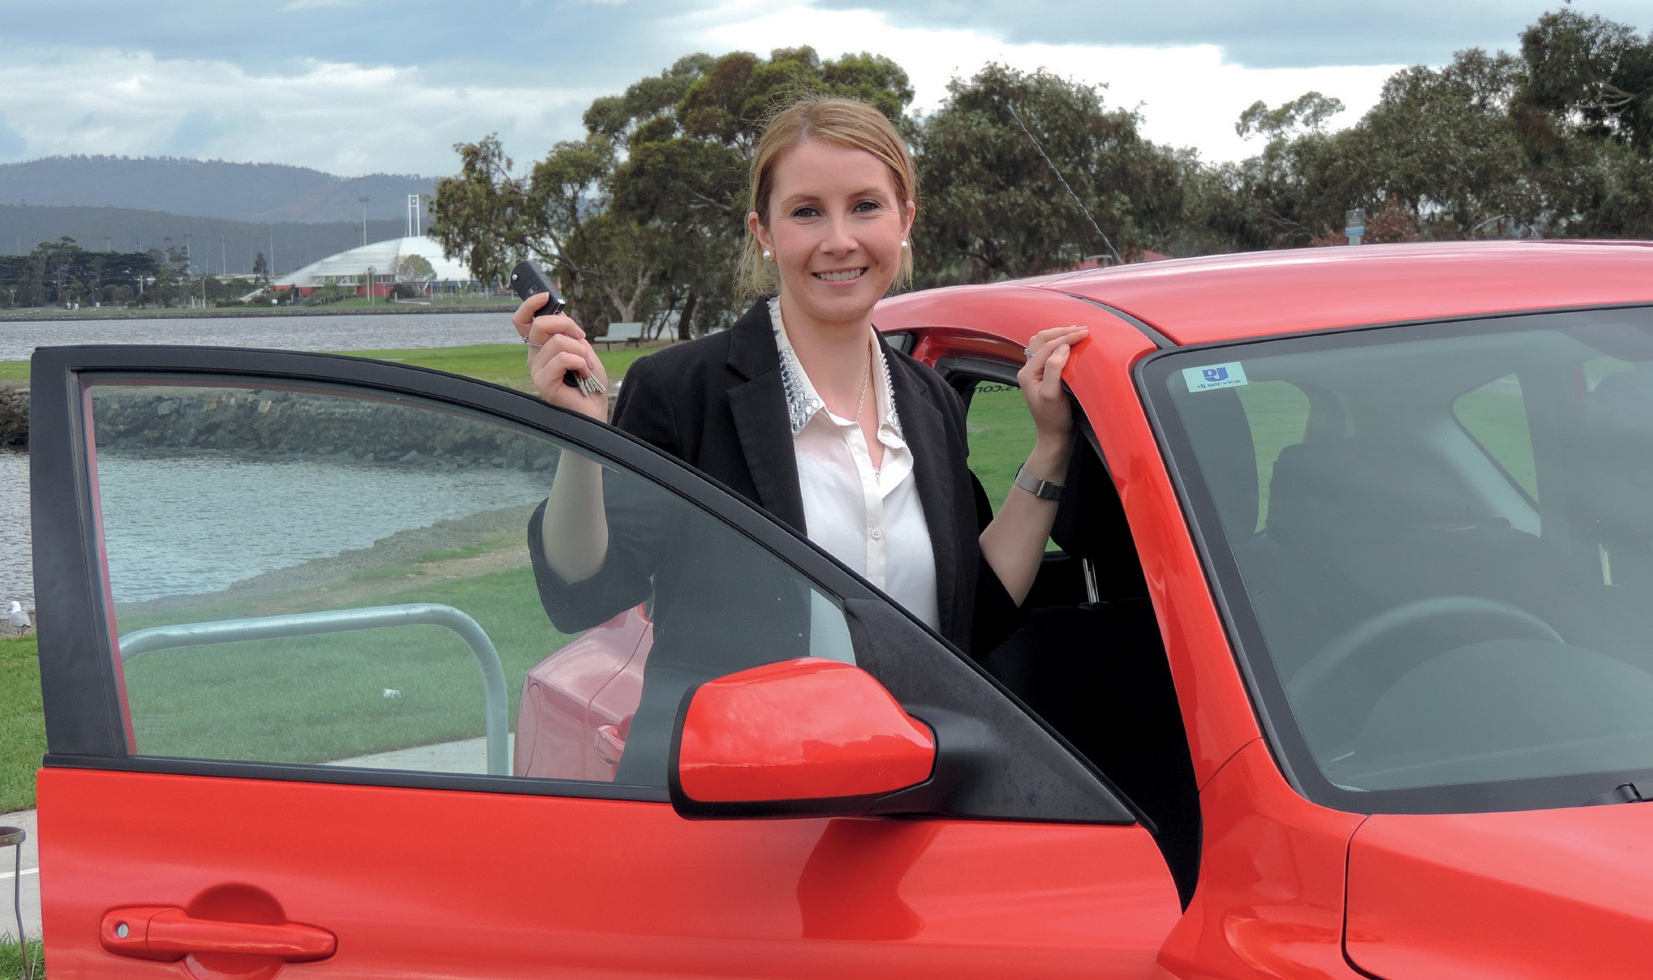

Key directions | Priority actions 2017-2019
Improve the Graduated Licensing System to reduce serious casualties for young road users (17-25 year olds). | Review a range of options under the Australian Graduated Licensing System Policy Framework to improve the Graduated Licensing System for novice drivers.
Introduce safety initiatives to reduce motorcyclist serious casualties. | Introduce a new pre-learner motorcycle training course including an on- road component at the commencement of the course.
 | Introduce initiatives to increase the use of protective clothing.
 | Introduce greater use of rear-facing automated speed cameras.
 | Increase motorcycle-focused enforcement.
Encourage safer road user behaviour through education and enforcement. | Promote safe behaviours through media campaigns.
 | Improve enforcement of high-risk road behaviours.

Safe Roads and Roadsides

What we know:
- Our two biggest challenges for making our roads and roadsides safer are managing road lane departures and collisions at intersections.
- We know that the infrastructure required to keep people safe and minimise risk on our roads is costly, but this can be justified by the number of serious injuries prevented and lives that can be saved.
- We can work towards increasing the level of safety by ensuring we are guided by best practice in road design, retrofitting safety features on existing lengths of road and using evidence to target our most unsafe roads.
- Although 2+1 and 2+2 road configurations with centreline barriers are the most effective option in terms of reducing the number of serious casualties, we know that they are an expensive option.
- Funding is limited, so we must prioritise installation of high cost treatments on high risk roads and implement lower cost, but effective treatments more broadly across the road network.

Key directions | Priority actions 2017-2019
Reduce run-off-road and  head-on crashes through improved infrastructure. | Accelerate installation of flexible safety barrier based on crash risk.
 | Expand the audio-tactile line marking program.
 | Undertake shoulder sealing where a known crash problem exists.
Reduce the severity of intersection crashes through improved infrastructure treatments. | Investigate and implement innovative intersection treatments.
Encourage the latest thinking in safe road design (the Safe System approach). | Develop a program for building Safe System knowledge of state, local and industry engineers.
Reduce serious casualties through improved delineation (e.g. line marking). | Improve levels of delineation on high risk roads to reduce run-off-road and head-on crashes.

Safe Vehicles

What we know:
- With Tasmania having the oldest vehicle fleet in Australia, we know many Tasmanians are not benefiting from the improved safety features of new vehicles.
- It is important to get as many 5 star vehicles as possible into the Tasmanian vehicle fleet so that maximum safety benefits can be realised.
- Antilock Braking Systems (ABS) for motorcycles have significant safety benefits.

Key directions | Priority actions 2017-2019
Improve the star rating of Tasmania’s vehicle fleet to include vehicles with better safety features. | Ensure high minimum safety specifications for all new passenger and light commercial vehicles in the Tasmanian Government fleet.
 | Actively promote vehicle fleet safety standards for commercial fleets.
Increase the number of motorcycles with ABS. | Introduce measures to promote or incentivise the uptake of motorcycle ABS.

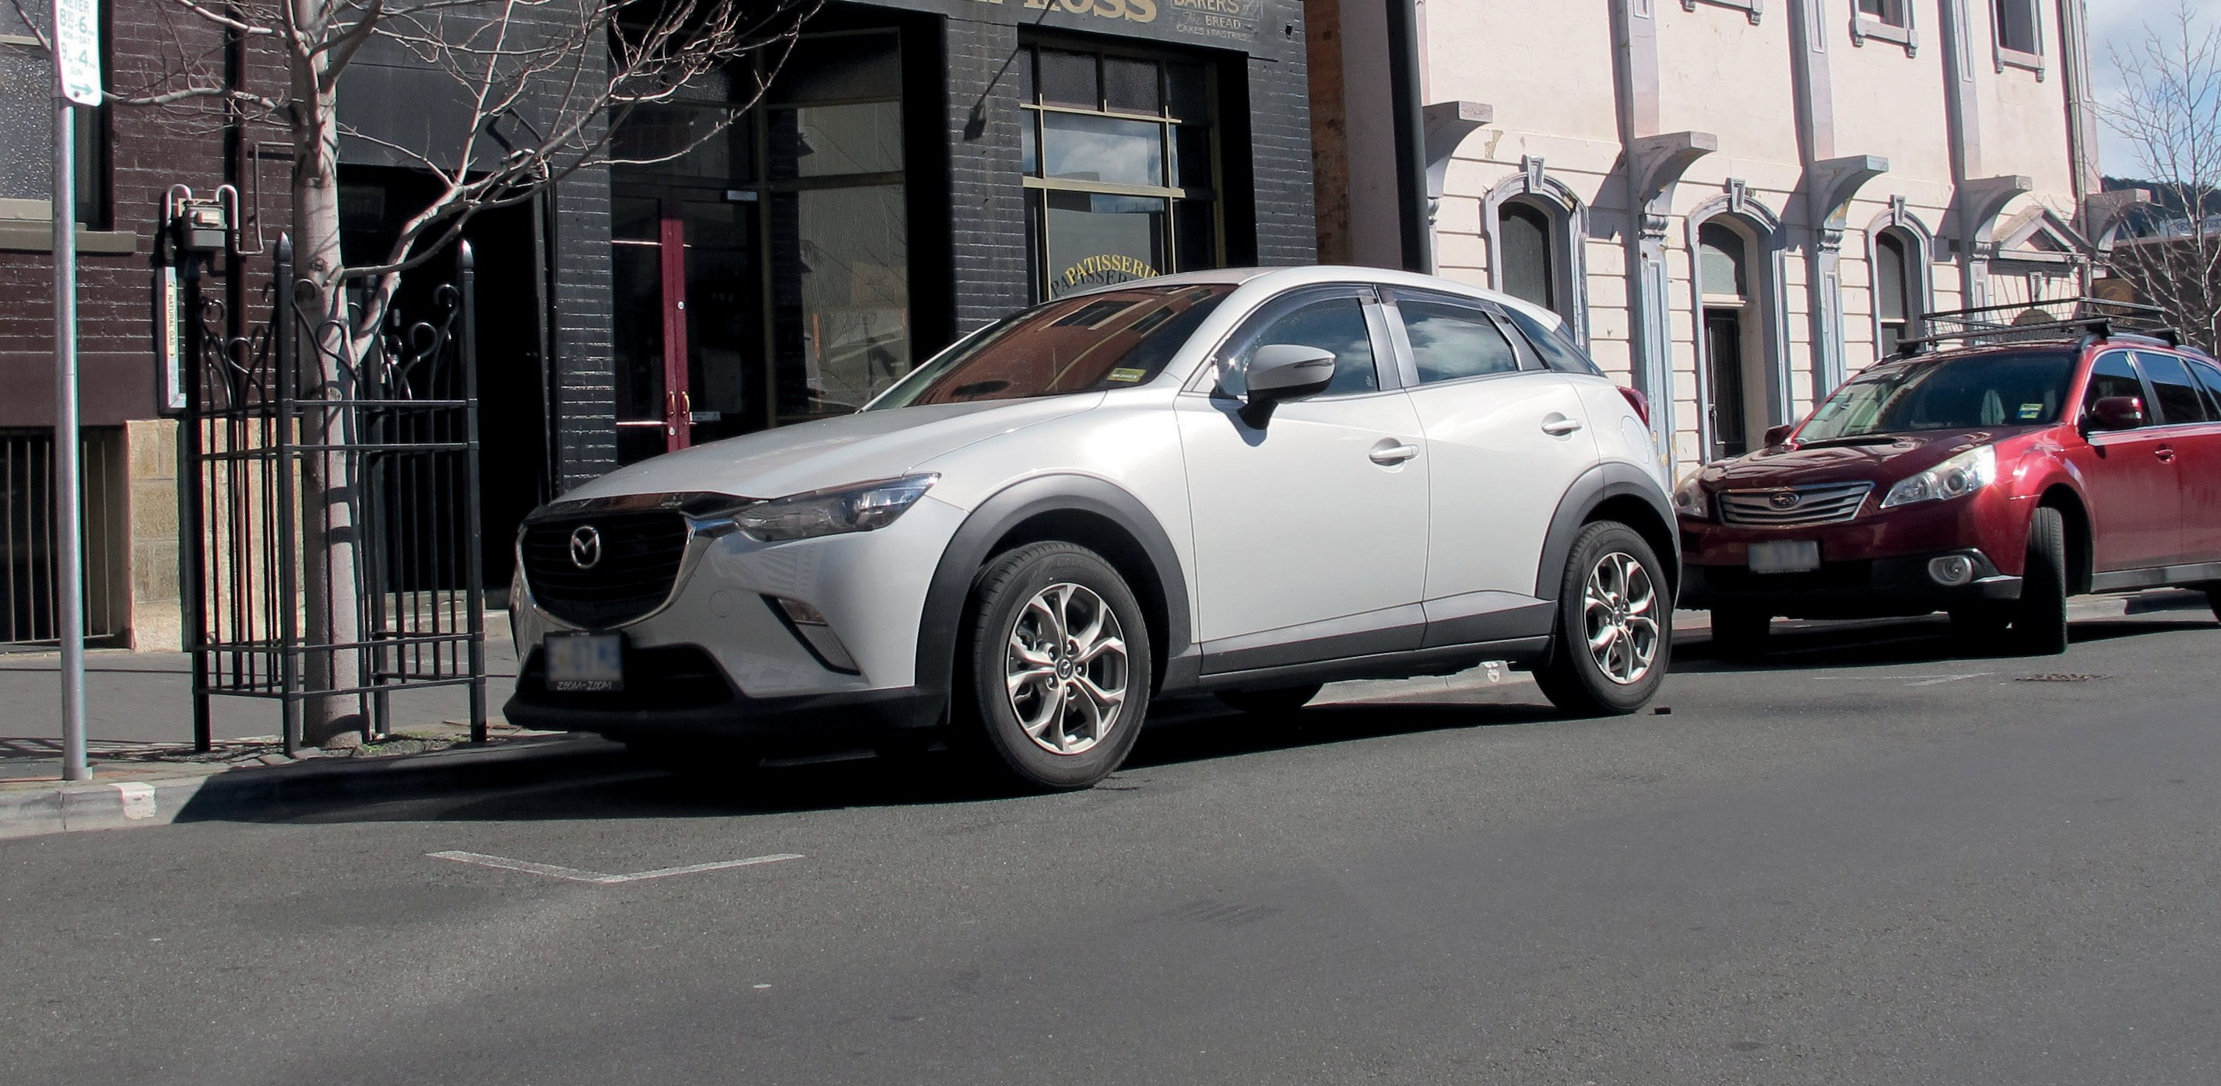

Safe Speeds

What we know:
- The higher the travel speed, the greater the chance of being involved in a crash and the more severe the consequences will be if a crash occurs.
- Some speed limits may currently be set at a higher level than our bodies can tolerate should a crash occur. It is important that we understand the benefits of having speed limits appropriate to the safety features on our roads.

Key directions | Priority actions 2017-2019
Establish speed limits that are more appropriate to the safety features of individual roads. | Improve speed limit setting guidelines to promote uniform, sensible speed limits based on infrastructure standards and safety features and have fewer speed zone changes.
 | Undertake an assessment of speed limits on individual 100 km/h roads, taking into account crash risk and road features.
Increase enforcement through technology to reduce speed related serious casualty crashes. | Introduce point to point speed cameras on high risk rural roads.
 | Increase the number of fixed speed cameras in urban areas.

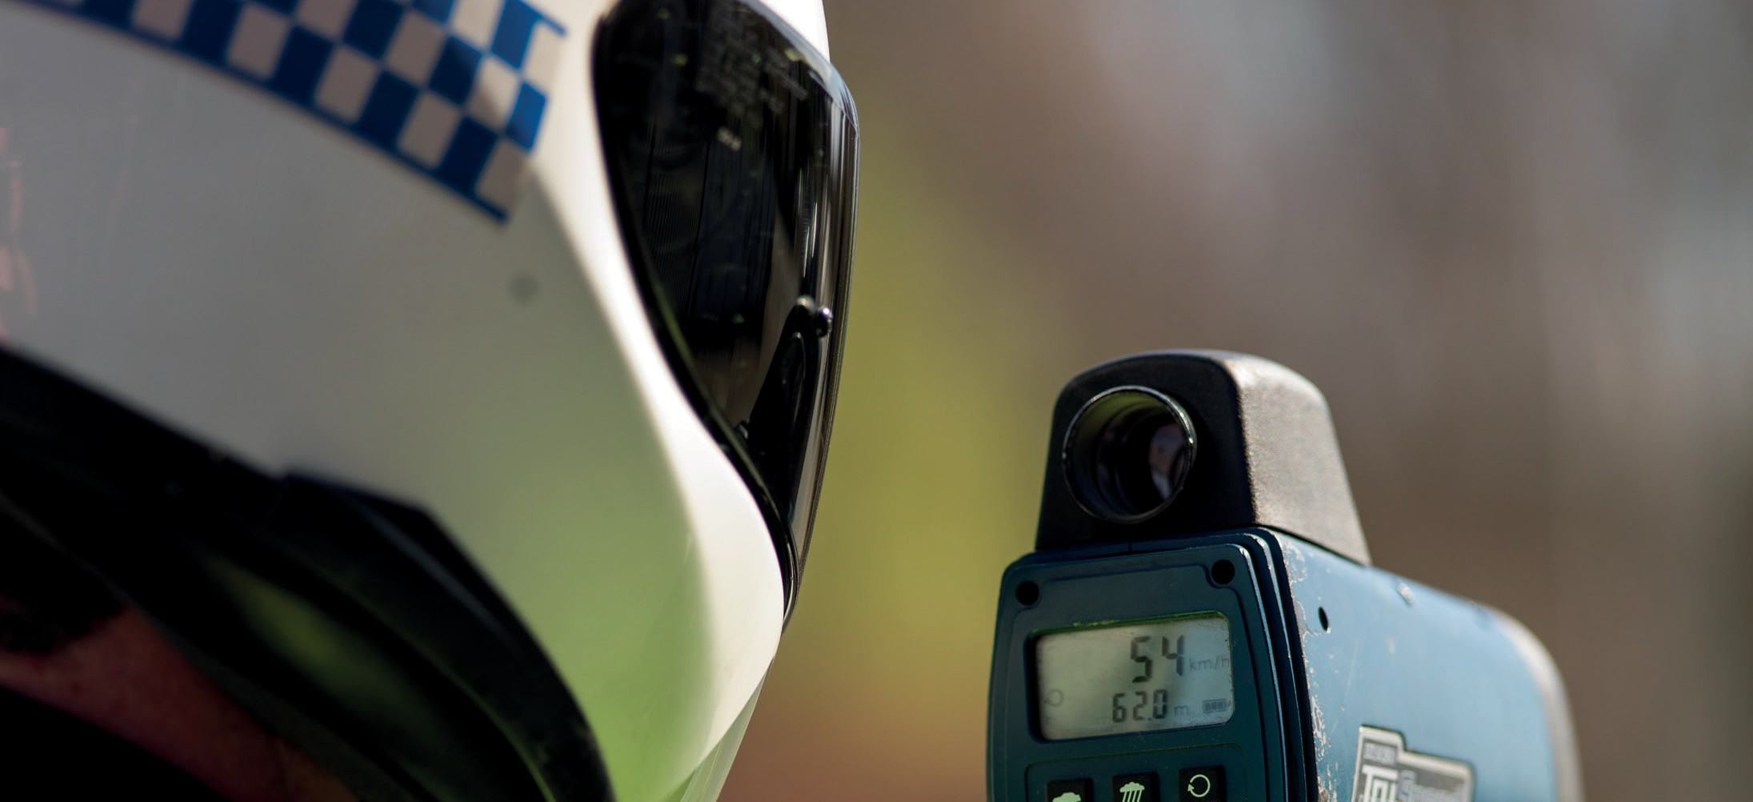

Department of State Growth Road Safety Branch
Towards Zero Action Plan 2017-2019
GPO Box 536
Hobart TAS 7001 Australia
Phone: 03 6166 3239
Email: towardszero@stategrowth.tas.gov.au Web: www.towardszero.tas.gov.au

© State of Tasmania December 2016

